COMMUNITY SHARE OFFER DOCUMENT

The Cottage Tavern Community Benefit Society Limited
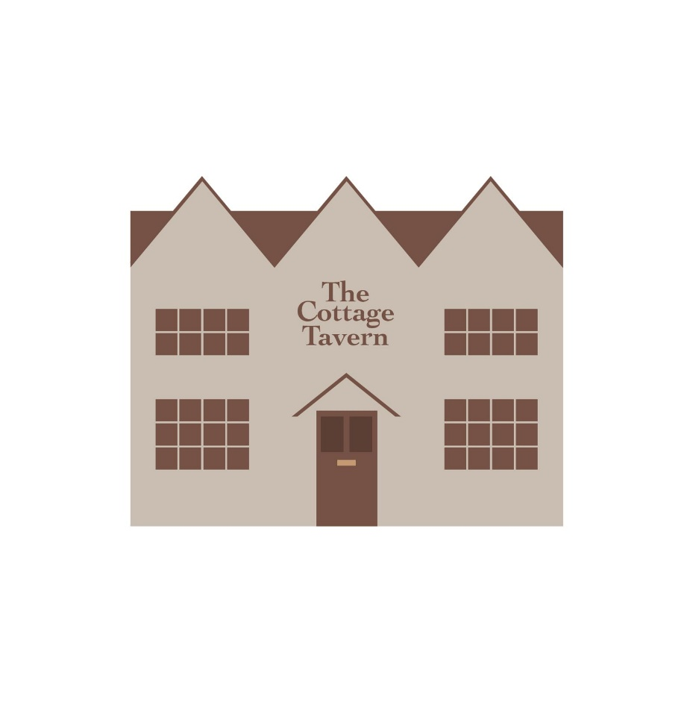
(FCA registered as a Community Benefit Society – 9723)

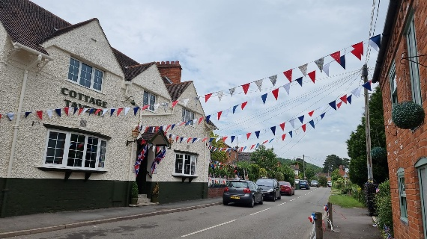
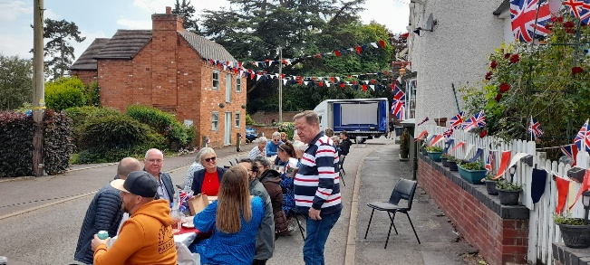
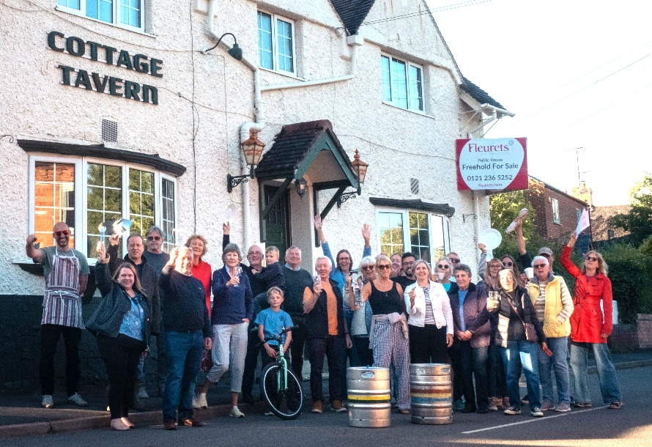

Contents
The Cottage Tavern Community Benefit Society Limited 1
1. Background and Executive Summary 3
1.1 About the Cottage Tavern Community Benefit Society Limited 3
2. Business Model 5
2.1 How the pub will make money 5
2.2 What makes this different? 5
2.3 Community activities and social impact 6
2.4 How the community has shaped this plan 6
2.5 Ongoing community involvement 6
3. Finances 7
3.1 Capital Requirements 7
3.2 Sources of Capital 8
3.2 Community shares 8
4. Risk Factors 14
5. Becoming a Member through Shares 15
5.1 Who can become a member? 15
5.2 Member Involvement 16
5.3 Financial benefit to the investor 16
5.4 Withdrawal of Shares 17
5.5 Use of Funds achieved through Shares 19
5.6 Ongoing use of funds and profits 19
5.7 Compliance with Society Rules 20
6. The Cottage Tavern Community Benefit Society Limited share offer declaration 21
COMMUNITY SHARE APPLICATION FORM 22

This Share Offer Document has been prepared by The Cottage Tavern Community Benefit Society Limited, a Community Benefit Society registered under the Co-operative and Community Benefit
Societies Act 2014. It is structured in accordance with Plunkett UK guidance for community
share offers.

The Cottage Tavern Community Benefit Society Limited
The Cottage Tavern in the heart of the Community : Towards a Community-Owned Public Amenity

This share offer document describes a social investment with financial benefit to the investor

Background and Executive Summary

The Cottage Tavern has been a successful village pub since it was built in 1837 on land that is thought to have belonged to the estate of the Earl of Warwick. It was rebuilt in 1907 following a fire.
The County Records Office website (ourwarwickshire.org.uk) shows a photograph of the Cottage Tavern from 1900 which is familiar to many Ashorne residents and was on display in the pub when it was last open. The image shows the building with two gables instead of the current three with some cricket players standing outside, illustrating the pub’s longstanding tradition of being involved with the local cricket club. This tradition still stood until the pub closed in 2025.
Ever since its doors had opened, the Cottage Tavern, Ashorne had been the venue for celebrations, commiserations, festivals, sporting events, community get-togethers and social support ever since its doors opened. Previous landlords’ lack of focus on the community’s needs led to its closure..

1.1 About the Cottage Tavern Community Benefit Society Limited

Determined not to lose the pub forever, a community benefit society was set up in 2026 and registered with the Financial Conduct Authority (FCA Registered No. 9723). The aim is to return the Cottage Tavern to its former glory and ensure that it sits, once again, at the heart of the village. This time it will have an extended offer to suit the wide range of needs within Newbold Pacey and beyond, including walkers and cyclists, families and friends and those who would like to visit a friendly, local, rural hub.
Five founding members have prepared a business plan and community share offer, supported by Plunkett UK (a charity aiming to help rural communities create and run democratic community-owned businesses. The charity strives for resilient and inclusive rural communities, and has promoted the community ownership model for over 100 years).
Fundraising submissions have already been made and we are inviting involvement through this share offer. We believe that community ownership will provide a long-term solution that prioritises community benefit over private profit.

1.1.1 Purpose
The Cottage Tavern Community Benefit Society Limited plans to acquire, own, and operate the village public house as a financially sustainable, community-owned asset that delivers social, economic, and wellbeing benefits to the local community.

1.1.2 Vision
To secure a thriving, inclusive and financially sustainable village pub that reduces isolation, supports local employment and serves as a long-term community asset.

1.1.3 Community Impact and Objectives
A thriving pub will provide local employment, social space, services, and support for local suppliers, as well as a regularly open public space to encourage strong community cohesion, reduce rural isolation and support community wellbeing.

1.1.4 Legal Structure
The Cottage Tavern’s ownership by the Community Benefit Society (CBS) will enable it to be maintained as an asset for the community in perpetuity. The CBS has been registered with the Financial Conduct Authority (No. 9723). This vehicle will be used to acquire, operate and manage the pub.

1.1.5 Governance & Transparency
The Society is run in an open and accountable way, in line with its rules registered with the Financial Conduct Authority (FCA).
We are committed to being transparent with our members and the wider community.
- We operate under formal, FCA-registered rules
- We hold an Annual Members’ Meeting (AMM) each year
- We publish annual accounts for members to review
- We follow a one member, one vote system to ensure fairness
- The Business Plan is available on the website
- The Rules govern how the Community Benefit Society can be run. These have been laid out and approved by the Financial Conduct Authority. (See the Cottage Tavern Community Pub Limited rules on www.thecottagetavern.com.
- How decisions are made: Every member gets one vote, no matter how much they invest. This keeps things fair and democratic.
- Asset Lock: The property and assets are secured by an asset lock which means the pub and any profits must be used for the community. They cannot be sold off for private gain.

Business Model
The Cottage Tavern will operate as a professionally run pub with a strong community focus.
It will combine traditional income streams with a wider programme of community-led activities that make it more than just a pub.

2.1 How the pub will make money
Full details of the financial projections are provided in the business plan, available on the website. The main sources of income will be:
- Wet sales (drinks): A core part of the business, including local ales, wines, and soft drinks
- Food service: Simple, good-quality food designed to suit local demand and be commercially sustainable
- Events: Regular events to attract both local residents and visitors
- Community activities: Activities that bring people together while also generating income where appropriate
Our financial forecasts are based on realistic assumptions, and have been stress-tested to ensure the business can cope with lower trading periods.

2.2 What makes this different?
This is not a standard privately owned pub.
Because it is community-owned, the focus is not just on profit, but on:
- Keeping the pub open for the long term
- Supporting the local community
- Creating a welcoming, inclusive space for all
Any surplus made will be:
- Reinvested back into the pub
- Used to support community activities
- Used to improve facilities over time

2.3 Community activities and social impact
The Cottage Tavern will act as a village hub, offering a range of activities such as:
- Coffee mornings and informal meet-ups
- Events for older residents to reduce isolation
- Family-friendly events and seasonal celebrations
- Local clubs and interest groups (e.g. book clubs, hobby groups)
- Use of space for community meetings and local organisations
- Support for local suppliers, producers, and businesses
These activities are designed to:
- Strengthen community connections
- Provide a space for people of all ages
- Support wellbeing and reduce social isolation

2.4 How the community has shaped this plan
The business model and planned activities have been developed based on:
- Feedback from local residents
- Community discussions and engagement
- Evidence of what the village needs and values
This ensures the pub reflects what the community actually wants, not just a standard commercial model.
Full details are provided in the business plan, available on request.

2.5 Ongoing community involvement
The community will continue to play an active role through:
- Membership and voting rights (one member, one vote) as part of the community share
- Opportunities to volunteer and support activities
- Opportunities to join the management committee to have a greater say on how things are run
- Regular communication and updates
- Feedback channels to shape future plans
- Community input into events and use of the space
This means the pub will evolve over time, based on the needs of the village.

Finances
The Cottage Tavern Community Benefit Society Limited will raise the required capital through a community share offer and other funding options to acquire and refurbish the pub and to then operate it under a managed model. (see section 3 – finances).

3.1 Capital Requirements

The Community Benefit Society has identified that the total funding required is £380,000 with the following table identifying the principal areas of expenditure. All amounts are exclusive of VAT.
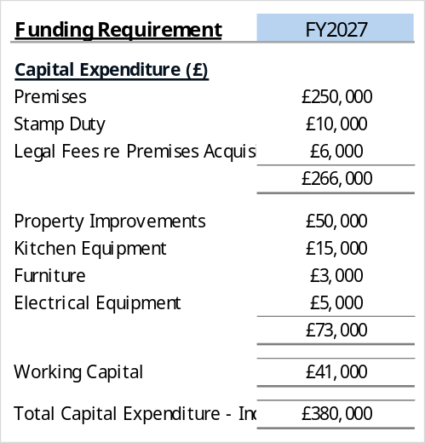
The figure given above is the maximum anticipated purchase price, members of the Society are currently in negotiation with the owners and shareholders will be kept updated.
Cash flow forecasts, profit and loss details and the balance sheet are detailed in The Cottage Tavern Community Benefit Society Limited’s business plan and appendices available on www.thecottagetavern.com

3.2 Sources of Capital
(How we plan to raise the money we need)
We plan to raise the total of £380,000 from a mix of community investment, grants, loans and local fundraising.

3.2.1 Planned funding sources
- Community Shares: £150,000
- Grants and local fundraising (various funders): £180,000
- Loans: £50,000
- Total: £380,000

3.2.2 Grants – current position
We currently have grants totalling £6,000 and are actively applying for grants to support the project, particularly for the purchase and refurbishment of the pub.
- Some grant applications have already been submitted and have been successful (as above)
- Others are in preparation or planned
- Decisions from funders are expected around the time of, or shortly after, the share offer launch
We will update members as soon as funding decisions are confirmed.

In the event that funding is not achieved through these routes, additional loans may be applied for. Investors will be kept fully up to date, if this is the case.

3.2 Community shares
Summary:
Share offer open and close dates | 29th June 2026 – 31st October 2026
Minimum investment per individual or organisation | £250
Maximum investment per individual or organisation | £55,000
Optimum target | £150,000
Minimum target | £100,000
Maximum target | £380,000

Note: Although technically the maximum funding amount detailed above could be raised via shares, this is not seen as likely.

3.3.1 Community Shares Explained
Community shares are a way for local people and supporters to invest in the pub and become members of the Cottage Tavern Community Benefit Society Limited (the Society).
These shares are different from ordinary company shares.
- They give you membership, not ownership for personal profit
- Shares do not increase in value. They may decrease in value if the total value of the property falls, or debts greater than assets accrue.
- Shares cannot be sold or transferred to someone else
- Shares may be withdrawn in the future, in the manner that the Society’s rules allow and with due consideration by the Community Benefit Society Limited ‘s board regarding affordability.
- Interest will be paid, when the Society is financially able to do so (estimated to be in year four of trading)
Each member has one vote, no matter how much they invest.
Minimum Investment
Minimum Investment in the Cottage Tavern Community Benefit Society Limited is £250 per person, (£1 of which is a non withdrawable and non interest-bearing membership share).
Maximum Investment
The Society will set a maximum investment level carefully, so that:
- No single investor has too much financial influence
- The Society is not over-reliant on one person
- Future repayments do not put the pub at risk
- The approach remains fair to all members
The Board can refuse or delay a withdrawal request if repayment would harm the Society.
However, if a member dies, their shares may need to be repaid in line with the Society’s rules and the terms of their estate.
Maximum investment per member: £55,000 per member (individual or organisation).

3.3.2 Share Offer Targets Explained
When raising money through community shares, it is important to set three levels:
Minimum Target - This is the lowest amount we must raise for the project to go ahead. This is £100,000.
If we do not reach this level, we will not be able to buy and open the pub in combination with funding raised through loans and grants.
Optimum Target - This is the ideal amount we want to raise £150,000.
It allows us, in combination with loans and grants, to:
- Fully refurbish the pub.
- Start trading with a strong financial position.

Maximum Target - This is the upper limit of what we will accept from investors. This is the full cost of the project i.e. £380,000.
It ensures we do not raise more money than we can responsibly use.

3.3.2 Confidence in the share offer
Advanced assurance from HMRC
The Cottage Tavern Community Benefit Society Limited has applied to HMRC for Advanced Assurance that this community share offer meets the requirements of tax benefits. NB: Individual investors must seek financial advice to identify whether they are eligible for tax benefits under EIS and other associated taxes.

3.3.3 What happens in different situations?

- If we do NOT reach the minimum target?

- The share offer will not proceed
- All money paid by investors will be returned in full

- What about costs already spent?
Some early project costs (such as surveys, legal fees, and preparing this share offer) may already have been incurred. These will be covered by:
- Grants
- Donations
- Contributions from founding members
Investors’ money will not be used to cover these costs if the minimum target is not reached.

- If we reach the optimum target

- The project will proceed as planned
- We will be in the strongest position financially
- This is the level we are aiming for

- If we reach the maximum target

We will manage this in one of the following ways:
- Option 1 (most likely):
We will close the share offer early once the maximum target is reached
- Option 2 (alternative approach):
We may keep the offer open for a short time but scale back investments proportionately (so everyone receives a fair allocation)
This ensures:
- Fairness to all investors
- The Society does not take more money than it needs
- Funds can be managed responsibly

Why this approach matters
Setting clear targets:
- Protects investors
- Shows strong financial planning
- Gives confidence to grant funders and lenders
- Helps ensure the long-term success of the pub

3.3.4 Share Offer Period and Possible Extension
The share offer has been open since 29th June 2026 and is expected to close on 31st October 2026.
However, the Management Committee has decided to extend the closing date by three months to offer oit out more widely.
When might we extend the offer?
We may extend the share offer if:
- We are close to reaching our funding target but need more time
- Grant funding decisions are still pending
- There is continued strong interest from investors
- Extra time would improve the overall success of the project
Any extension will be clearly communicated to all existing and potential investors.

Why this is important
If we did not include the option to extend, we would have to close the share offer on the original closing date, even if we were close to reaching our target.
Including this flexibility helps ensure:
- The best chance of raising the full amount needed
- Fairness to interested investors
- A stronger financial position for the Society

3.3.5 Death of a Member and Nomination of Shares
Nomination
A member may nominate a person or persons to whom any of their property in the Society (including shares) shall be transferred on their death.
A nomination:
- Must be made in writing in a form approved by the Society
- May be revoked or changed by the member at any time
- Will be recorded by the Society
The Society will act in accordance with a valid nomination upon receiving satisfactory evidence of death.

Limit on nominations
The Society may only transfer property under a nomination where the total value of the member’s shares and interest does not exceed the statutory limit set out in the Co-operative and Community Benefit Societies Act 2014 (or any subsequent legislation), £5,000 at the time of issue of this document.
Where the value exceeds this limit, the excess must be dealt with through the member’s estate.

Payment on death (without nomination)
If a member dies without a valid nomination:
- The Society may transfer or pay the value of the member’s shares to their personal representatives (for example, executors of the estate)
- The Society may require appropriate legal evidence before making payment

Form of payment
The Society may, at its discretion and in accordance with its Rules:
- Transfer the shares to the nominee or personal representative; or
- Pay the value of the shares to the nominee or estate
Any payment will be subject to the Society’s rules on withdrawal and its financial position at the time.

Effect of nomination
A valid nomination allows the Society to deal with the member’s shares without needing probate, up to the statutory limit.
This helps ensure:
- Faster payment
- Reduced administration
- Certainty for both the Society and the member’s family

Option to nominate the Society
A member may nominate the Society itself as the beneficiary of their shares. In this case, the value of the shares will be retained within the Society to support its long-term community purpose.

Important note
The Management Committee will manage payments on death carefully to protect the financial stability of the Society, particularly where large shareholdings are involved.

Risk Factors
As with any business, there are risks involved in this project. The main risks, provided in more detail in the business plan, include:
- Lower-than-expected income (for example, fewer customers than forecast)
- Higher costs than planned (such as refurbishment or operating costs)
- Wider economic conditions (e.g. cost of living pressures affecting spending)
- Volunteer capacity (reliance on community support and involvement)
These risks have been carefully considered, and steps have been taken to reduce their impact wherever possible.
How these risks are managed
The Society has developed a detailed Risk Register, which:
- Identifies all key risks
- Assesses their likelihood and impact
- Sets out clear actions to reduce or manage each risk
- Is regularly reviewed and updated by the Management Committee

Where to find more detail
Full details of all identified risks and how they will be managed can be found in the Cottage Tavern Community Benefit Society Limited’s Business Plan.

Becoming a Member through Shares
You are invited to buy shares and become a shareholder of The Cottage Tavern Community Benefit Society Limited. You will be investing in a community enterprise which aims to secure the long-term future of The Cottage Tavern as a pub and, most importantly, as a community hub.

5.1 Who can become a member?
To become a member, you must meet the following criteria:
- Be at least 18 (asset out in our Rules)
- Invest in the Society through the purchase of community shares
Membership is open to:
- Individuals
- Incorporated organisations (e.g. companies)
- Unincorporated organisations (e.g. clubs or community groups)
Organisations must nominate one person to act as their representative and vote on their behalf.

Can shares be bought as a gift?
Yes, shares may be purchased as a gift, subject to the Society’s rules.
- The recipient must meet the minimum age requirement
- Shares cannot be held in the name of someone below this age
- The Society may require confirmation that the gift complies with its Rules

Can people invest jointly?
Yes, joint investments are allowed (for example, couples, families, or groups of friends).
- One person must be nominated as the lead member
- This person will represent the group and exercise the voting rights
- Regardless of how many people are involved, there is still one vote per membership

5.2 Member Involvement
Active member involvement is essential to the long-term success of the Society.
Without engaged members, it becomes difficult to:
- Run the Society effectively
- Recruit future Management Committee members
- Maintain a strong community-led approach

How members can get involved
Members will be able to participate in a number of ways:
- Attend and vote at Annual Members’ Meetings (AMGMs)
- Attend additional members’ meetings and updates
- Stand for election to the Management Committee
- Volunteer to support events and activities
- Suggest ideas and provide feedback
- Help shape the future direction of the pub

Why this matters
This Society is owned and run by its members.
That means:
- Your voice matters
- Your involvement shapes the pub
- The strength of the project depends on the community staying engaged

5.3 Financial benefit to the investor

5.3.1 Interest payable
The business plan is built on the capacity to provide interest at 1% over the Bank of England base rate up to a maximum of 5%. Interest will be paid when the Society is financially able to do so (estimated to be in year four of trading).

5.3.2 Tax relief
By buying community shares in The Cottage Tavern Community Benefit Society, shareholders can help secure the future of our pub while also potentially benefiting from generous government-backed tax relief schemes.
For many investors, the real cost of investing can be significantly reduced through HMRC tax relief.
Example
A £1,000 investment could cost an eligible investor as little as £700 after tax relief under the Enterprise Investment Scheme (EIS)
This means the Government could effectively contribute up to half of your investment in helping save and reopen our community pub.
Potential tax benefits
Eligible investors may benefit from:
- 30% income tax relief through EIS once SEIS limits are reached
- Possible capital gains tax advantages
- Tax-free growth on qualifying shares held for the required period.
- Your investment in shares in the Society may qualify for ‘business relief’ under inheritance tax rules.
Important: We cannot advise you on your own financial or tax position or decision on whether to invest in The Cottage Tavern Community Benefit Society Limited.
Please seek your own independent financial and/or tax advice when deciding whether to invest in this share offer.

5.4 Withdrawal of Shares
The Society has built assumptions for share withdrawals into its financial forecasts, starting after the initial 3-year period. This ensures:
- Withdrawals are planned and manageable
- The Society can meet requests over time without risking stability
- Investors are able to achieve financial benefit from investments
Community shares are intended as a long-term investment in the pub and the community.
Any withdrawal is subject to the Society’s Rules, its financial position, and approval by the Management Committee.

5.4.1 When can shares be withdrawn?
- Shares will normally be eligible for withdrawal after a minimum period of 3 years from the date of investment
- Withdrawals are not guaranteed
- The Society must have sufficient funds and remain financially stable after any withdrawal

5.4.2 Share Withdrawal Policy
To provide clarity and fairness, the Society has adopted a Share Withdrawal Policy. This is available on the website www.thecottagetavern.com

5.4.2.1 Annual withdrawal limit
- The Society will allow withdrawals of up to 4% of total share capital per financial year
This limit helps ensure:
- The Society remains financially stable
- Cash flow is protected
- The pub can continue to operate successfully

5.4.2.2 How withdrawals are handled
- Requests will be dealt with on a first come, first served basis
- Members must submit a formal withdrawal request

5.4.2.3 If requests exceed the annual limit
If total withdrawal requests are greater than the 4% annual limit:
- Withdrawals may be reduced proportionately across all applicants, and/or
- Any remaining balance will be carried forward to the following year
This ensures fairness to all members.

5.4.2.4 Right to suspend withdrawals
The Management Committee may:
- Refuse or delay withdrawals if making payments would harm the Society
- Suspend withdrawals temporarily in difficult financial circumstances
This is to protect the long-term future of the pub.

5.4.2.5 What this means in practice
- You should view this as a long-term investment (at least 3–5 years)
- Withdrawals will depend on the Society’s financial health
- The policy is designed to balance fairness to members with protecting the business

5.5 Use of Funds achieved through Shares
All money raised through this share offer will be used only for the purposes of the Society and in line with its Rules.
Initial use of funds
The funds raised will be used for:
- Purchase of The Cottage Tavern
- Essential refurbishment and improvements
These costs are set out in detail in the Capital Requirements section and the Business Plan.

5.6 Ongoing use of funds and profits
The Society is a Community Benefit Society, which means it exists to benefit the community, not private individuals.
Any surplus (profit) generated by the pub will be used in line with the Society’s Rules and may be applied to:
- Reinvesting in the pub (maintenance, improvements, new facilities)
- Building financial reserves to ensure long-term sustainability
- Supporting community activities and initiatives
- Making donations to local good causes and charities

What this means for investors
- Investors should not expect capital growth in the value of their shares
- Interest paid on shares will be limited, as described above. The decision to pay interest is at the discretion of the management committee and will only be paid once there is financial profit within the pub.
- The main return is social benefit, alongside the long-term security of the pub as a community asset
- In the event that the pub closes on an ongoing basis and once the building is sold, all proceeds will be distributed amongst the shareholders up to the maximum value of their original investment plus, at the discretion of the Management Committee, any accrued but unpaid share interest.

5.7 Compliance with Society Rules
The use of funds and any distribution of surplus will comply with:
- The Society’s FCA-registered Rules (particularly those relating to application of profits), and
- The principles set out in the Community Shares Handbook for Community Benefit Societies
- The Community Shares Finance Guide
This ensures that:
- Funds are used responsibly
- The community benefit is protected
- The Society operates in line with best practice

The Cottage Tavern Community Benefit Society Limited share offer declaration
By investing, members confirm they understand that capital is at risk, community shares are not
transferable, and that they accept the Society Rules.
Signed on behalf of The Cottage Tavern Community Benefit Society Limited
Chair (Dale Robinson) : Secretary (Kate Freeman): 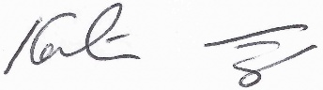
Date: 24.08.2026

IMPORTANT: Community shares are withdrawable share capital. They are not transferable, are not protected by the Financial Services Compensation Scheme, and may only be withdrawn in accordance with Society Rules. Investors have no recourse to the Financial Ombudsman Service. Capital at risk you could lose some or all of your money and have no rights to statutory compensation or complaint.

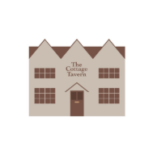
COMMUNITY SHARE APPLICATION FORM
The Cottage Tavern Community Benefit Society Limited
Registered under the Co-operative and Community Benefit Societies Act
Registered with the Financial Conduct Authority (FCA)
IMPORTANT NOTICE
Please read the Share Offer Document carefully before completing this Application Form.
Community shares are:
- Withdrawable shares in a Community Benefit Society
- Not transferable (except in limited circumstances such as death)
- Not protected by the Financial Services Compensation Scheme (FSCS)
- Not regulated investments under the Financial Services and Markets Act 2000
Your capital is at risk and you may not be able to withdraw your shares when you wish to
Your capital is at risk and you may lose some or all of your money

For ease of admin, a google form is available for applicants to use, please

CLICK HERE

If you would prefer to fill in the document in hard copy, please print the following:

- 1. APPLICANT DETAILS
Applicant Information | Details
Full Name
Address
Postcode
Telephone Number
Mobile Number
Email Address

- 2. SHARE APPLICATION
I wish to apply for membership of The Cottage Tavern Community Benefit Society Limited and apply for:

- £ ________________worth of shares

Minimum investment: £250
Maximum investment permitted: £55,000 (subject to Society rules and any statutory limits)

3. PAYMENT METHOD
Please indicate payment method:
- Bank Transfer - Cheque
- Online Payment - Other __________________

Bank Details
Account Name: The Cottage Tavern Community Pub
Bank: The Co-operative Bank
Sort Code: 08-92-99
Account Number: 67516362-00
Reference: Surname + ‘Shares’
Cheques payable to: The Cottage Tavern Community Pub

4. MEMBERSHIP DECLARATION
I confirm that:
- I have read the Share Offer Document dated 28.06.26 and the Business Plan dated 15.09.26.
- I understand that this is an investment in withdrawable share capital in a Community Benefit Society.
- I understand that my capital is at risk.
- I understand that the value of shares may reduce and I may lose some or all of my investment.
- I understand that shares are withdrawable only in accordance with the Society’s Rules and Share Withdrawal Policy.
- I am aged 18 or over.
- I agree to become a member of the Society and to be bound by its Rules.
- I understand that each member has one vote regardless of shareholding.
- I am investing on my own behalf unless otherwise stated in this application.

Signed (or name if filled in online): ___________________________

Print Name: _______________________ Date: ____________________________

- 5. JOINT APPLICANT
Joint applications may be accepted subject to the Society’s Rules.
Joint Applicant Information - | Details
Full Name (applicant 2, in addition to named person above)
Address
Email Address
Telephone Number
The first named applicant, above, shall be treated as the primary contact for membership purposes.
- I confirm that I (as joint applicant) am 18 years or over

Signature (or name if filling in online) 2: _______________________

Date: ____________________________

- 6. CORPORATE / ORGANISATION APPLICATIONS
Applications from incorporated organisations, clubs, societies, charities or businesses may be accepted subject to the Rules.
Organisation Name
Registration Number
Registered Address
Authorised Representative
Position
Email Address
I confirm that I am authorised to make this investment on behalf of the organisation.

Signature (or name if filling in online): _______________________

Date: ____________________________

- 7. GIFTED SHARES
I confirm that this investment is being made as a gift to another person (the details of the donor are the same as the applicant details above).

PERSON RECEIVING THE SHARES (GIFTEE / MEMBER)
RECIPIENT DETAILS
Full Name
Address
Postcode
Telephone Number
Email Address
- I confirm that the person receiving these shares is aged 18 or over and is eligible to become a member of The Cottage Tavern Community Benefit Society Limited.
- I understand that the person receiving the shares will be entered into the Society's Register of Members and will become the legal holder of the shares.
- I confirm that the information provided above is true and accurate.

Donor Signature (or name if filling in online): __________________________
Date: __________________________

Important: Community Benefit Society shares may only be held by persons aged 18 or over. Where shares are gifted, the recipient becomes the member of the Society and their details will be entered into the Society's Register of Members.

8. NOMINATION
Under the Co-operative and Community Benefit Societies Act 2014, you may nominate a person or organisation to receive your shares or property interest upon your death.
I nominate:
Nominee Details
Full Name
Address
Relationship
Percentage (if multiple nominees)

- I confirm that I, as nominee, am 18 years or over

Signature (or name if filling in online): _______________________ Date: __________________________

(Please add additional pages for additional nominees)
9. SHARE WITHDRAWAL POLICY SUMMARY
Applicants should note:
- Shares are withdrawable but not transferable except in limited statutory circumstances.
- Share withdrawals are entirely at the discretion of the Committee.
- Withdrawals may only be permitted where the Society has sufficient reserves and working capital.
- The Society may limit the total amount of shares withdrawn in any financial year.
- The Society may suspend withdrawals where necessary to protect the financial stability of the Society.
- Full details are contained within the Society’s Share Withdrawal Policy.

- 10. FOR ANTI-MONEY LAUNDERING
The Society may request proof of identity and address in some cases and
reserve the right to request further personal information, and refuse an application
By signing this form, I confirm that:
- the funds invested are from legitimate sources;
- I am investing for lawful purposes;
- I will provide identification documents if requested.

11. CHECKLIST
Please provide the following if requested:
Proof of Identity
- Passport
- Driving Licence
- Other Government ID

Proof of Address
- Utility Bill
- Bank Statement
- Council Tax Bill

Documents should normally be dated within the last three months

- 12. DATA PROTECTION / GDPR
The Society will process your personal data in accordance with UK data protection legislation.
Your information will be used for:
- administering your membership;
- maintaining statutory registers;
- communicating with members;
- administering the community share offer;
- complying with legal and regulatory obligations.
Your information will not be sold to third parties.
- I consent to receiving updates and communications from the Society.
Preferred communication method:
- Email
- Post
- Telephone

- 13. COMMUNITY DONATION OPTION
If the share offer exceeds the maximum target, or if any overpayment arises, I would like:
- The excess returned to me
- The excess treated as a donation to the Society
Optional additional donation:
£ ___________________

14. STANDING ORDER / FUTURE INVESTMENT INTEREST
- I would be interested in making regular future contributions to support the Society.
Preferred monthly contribution:
£ ___________________

15. TAX RELIEF
If the Society obtains eligibility for any tax relief scheme (such as Enterprise Investment Scheme Tax Relief or successor schemes), the Society may contact investors with further information.
The Society cannot provide tax advice and investors should seek independent professional advice.

16. SHARE CERTIFICATE REQUEST
- I would like a printed share certificate.
- Electronic certificate preferred.
RETURNING YOUR APPLICATION
Please return completed forms to:
Kate Freeman, Secretary
The Cottage Tavern Community Benefit Society Limited
Central Cottage
Ashorne
CV35 9DR

Or email a scanned copy to thecottagetavern@yahoo.com
NOTES TO APPLICANTS
- Community shares are long-term investments intended primarily to support community benefit.
- Shares are not transferable except in limited statutory circumstances.
- Withdrawal of shares is subject to:
- Society Rules
- available reserves and cashflow
- Committee approval
- the Share Withdrawal Policy
- Interest on shares is not guaranteed.
- Investors should consider taking independent financial advice before investing.
DECLARATION
I confirm that the information contained within this application is true and accurate to the best of my knowledge.

Signature (or name if filling in online): ___________________________
Print Name: _________________________
Date: ______________________________
FOR OFFICE USE ONLY
Application Received
Amount Paid
Payment Cleared
Member Number
Shares Issued
Entered on Share Register
Share Certificate Issued
AML Checks Completed

The Cottage Tavern Community Benefit Society Limited
The Cottage Tavern in the heart of the Community : Towards a Community-Owned Public Amenity

