Business Plan

The Cottage Tavern Community Pub Limited
(FCA registered as a Community Benefit Society – 9723)
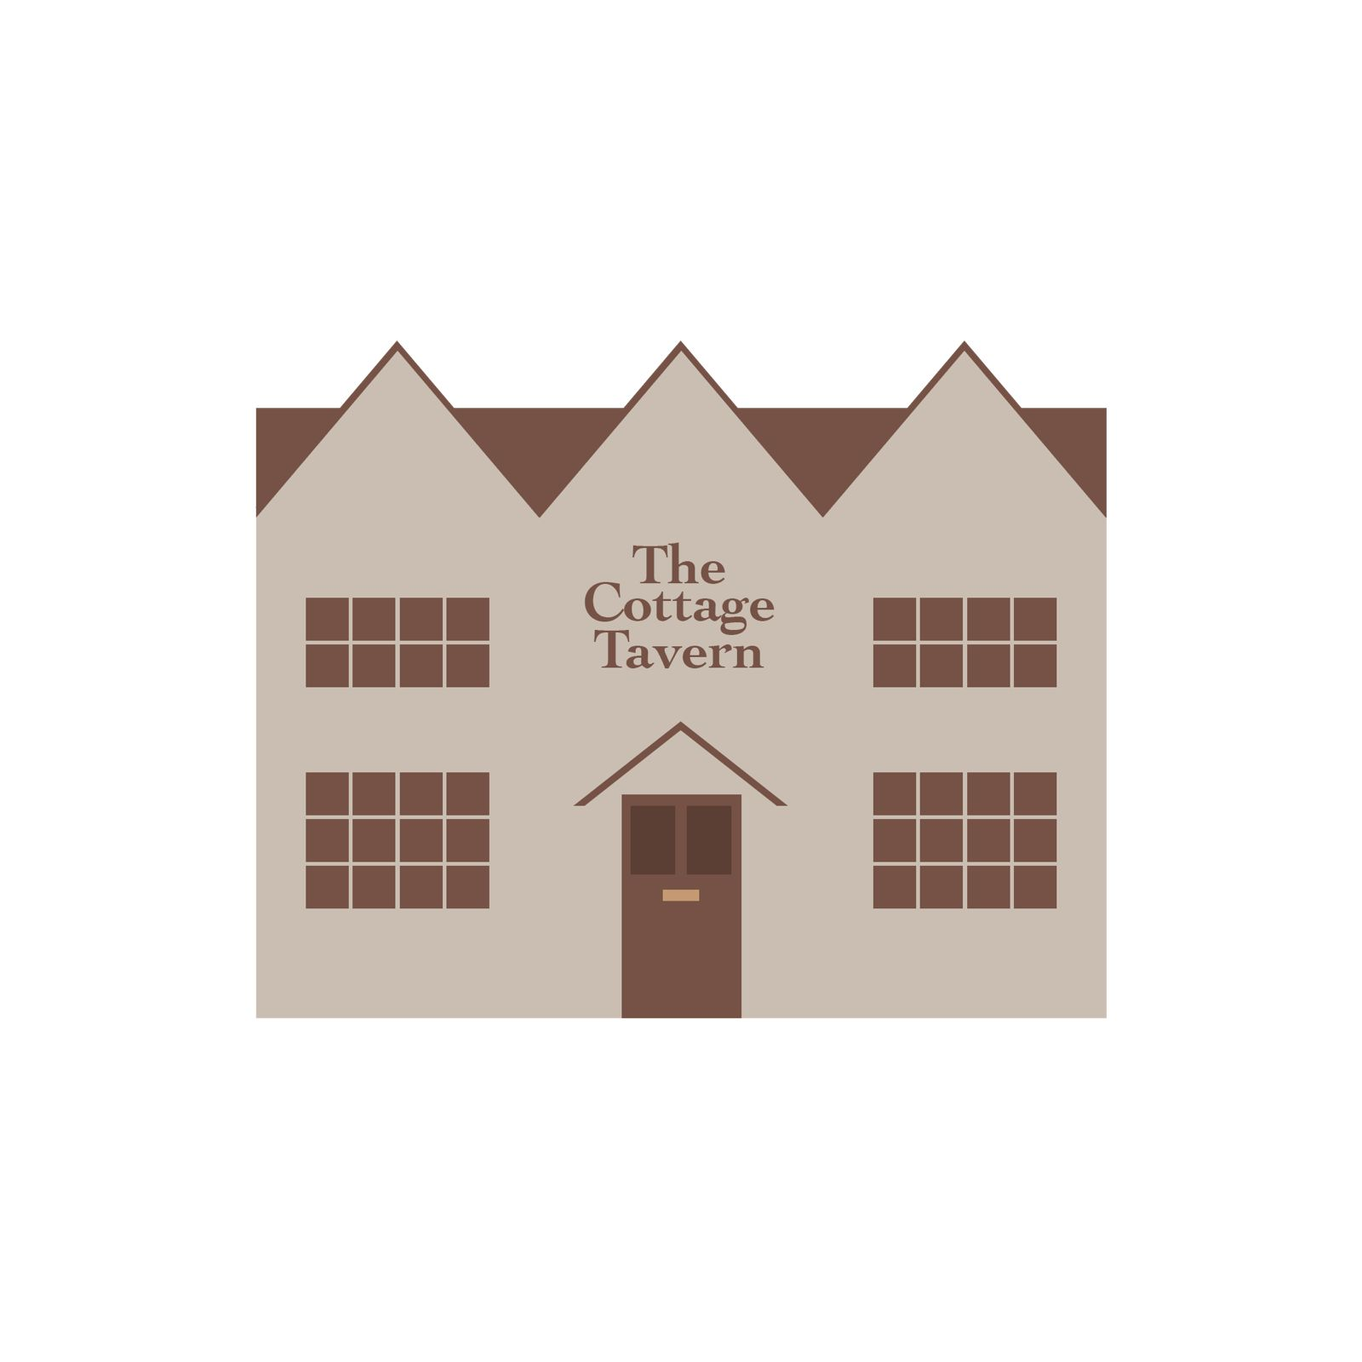

1. Executive Summary

1.1 Purpose of This Plan

The business plan has been prepared to demonstrate that the society has a clear community purpose, robust governance, a viable trading model, and a prudent financial strategy consistent with funder and Financial Conduct Authority (FCA) expectations and will be used to support:
- a Community Share Offer
- engagement and review by Plunkett UK; and
- applications to grant funders and local authorities.

Name: The Cottage Tavern Community Pub Limited.
Purpose: To acquire, own, and operate the village public house as a financially sustainable, community-owned asset that delivers social, economic, and wellbeing benefits to the local community.
The Opportunity: The village pub has been closed for an extended period due to the previous landlords’ lack of focus on the community’s needs. Community ownership will provide a long-term solution that prioritises community benefit over private profit.
Proposal: The society will raise the required capital through a community share offer and other funding options to acquire and refurbish the pub and to then operate it under a managed model.
Community Impact and Objectives: A thriving pub will provide local employment, social space, services, and support for local suppliers, as well as a regularly open public space to encourage strong community cohesion, reduce rural isolation and support community wellbeing.
As a Community Pub, the Cottage Tavern’s ownership by the Community Benefit Society (CBS) will enable it to be maintained as an asset for the community in perpetuity.

2. The Society – Legal Structure

- A Community Benefit Society (CBS) has been registered with the Financial Conduct Authority (No. 9723).
- This vehicle will be used to acquire, operate and manage the pub.

3. The Community and Market Need

  - The Village

Ashorne, in the parish of Newbold Pacey and Ashorne, Warwickshire, is an isolated rural community with no shop or church to pull people together. The village does have a village hall which is available for bookable functions, but the community is mourning the loss of the village pub which, for many years, has provided a frequently open space for people to pop into when they were feeling in need of community connection.
The village hall is rented out to community groups and also offers a venue for community events.
Members of the village events committee are working closely with the CBS. In the past and in the future, they will continue to work together to ensure that events planned by either do not clash and thereby avoid competing for the same potential ‘customers.’
Concerning Ashorne itself, it has a population of c300. The village has limited public transport links with only two buses each way per day. The nearest shops and doctor’s surgery are three miles away in Wellesbourne. Historically there has been a high social value attached to the pub by the community.
Detailed census data is available in Appendix 5.

  - Community Support

- There has been evidence of strong community backing through meetings, surveys, and pledges.
- Through these there is a clearly identified demand for food, drink, events, community activities and services
- A community engagement survey was conducted in 2025. The detailed survey results are outlined in Appendix 2, but selected extractions include:

Question - What have you missed most about having a local pub that is consistently open? /Things I enjoyed.
  - Definitely the wood burners in the dark winter days, seeing familiar faces, the odd pint and a nice fish pie.
  - A nice cosy local pub I can walk to.
  - The social interaction.
  - Good food.
  - Seeing the local people, having that sense of community within the village to socialise, celebrate occasions and reminisce.
  - The social, the food (thinking back to the [previous landlord] days), the reason for a walk into the village.
  - Dinner out with family, either a quick, affordable meal during the week or a get together on the weekend. Also, a coffee on the weekend after a walk. And of course, catching up with the neighbours

3.3 Market Context

Ashorne lies at the centre of a triangle between Stratford upon Avon, Warwick, and Leamington Spa, being between six to eight miles from each. It is a peaceful rural location with a successful cricket club which is situated on the land between the main village and the small hamlet of Newbold Pacey.
The village is host to a number of village groups – a Women’s Institute, book club, craft group, crib team, whist group, to name but a few, with these groups previously also making use of the pub. Additionally, the pub has also been a stop off or meeting place for walkers (particularly those walking to or from the nearby Warwickshire Wildlife managed Oakley Woods) and cyclists and has also hosted wakes linked with families using the nearby South Warwickshire Crematorium, which is about a mile away.
The nearest big village, Wellesbourne, is rapidly approaching the size of a small town but is three miles away. This is the location for two curry houses, two cafes, and two pubs. There are smaller villages nearby.
Moreton Morrell, which has a newly refurbished village pub offering wet sales only and having no on-site parking. However, it does have a school, a church and an agricultural college.
Lighthorne, which had a larger pub offering wet sales and food and a large parking area, though this pub is currently closed. The village does have a church.

  - Market for Community Pubs

In recent years, there has been steady growth across the country in the number of community owned pubs. Currently, there are approximately seventy such ventures operating successfully in the UK and each one has been set up to best suit its community and circumstance. Locations of these pubs can be identified at the CAMRA website - www.camra.org.uk.

Examples include:
- The Old Crown which set the pace in 2003 when it became Britain’s first registered co-operatively owned pub. It is owned by a collective of around 150 local, national, and even international customers and supporters. It thrives today as it serves the very best of real ales, most brewed by Hesket Newmarket Brewery which stands at the rear of the pub, and a range of appetising and wholesome home-cooked meals and snacks.
- The Ivy House in Nunhead was the first pub saved using the Community Right to Bid and is also London’s first co-operative pub. It is a Grade II listed 1930s building. The Ivy House serves good food and an excellent selection of craft beers and real ales.
- The Hollybush was bought by the villagers of Seighford in 2012 and provides a community facility for those interested in good beer, delicious food, and a friendly atmosphere. They now have over seventy shareholders, who have helped the project by giving their money, skills, and time to the local community.
- The Anglers Rest in Bamford is owned by three hundred community shareholders and as well as being a pub it is also the village post office and café. It was one of the first pubs to be listed as an Asset of Community Value (ACV). We have taken advice from the team who saved the Anglers Rest.
- Norton Lindsey’s New Inn raised £342k in equity, £100k loan and £50k in grants. Now in its eighth year it offers drinks, food, events, and a shop.
- Woodcroft’s Rising Sun was saved from developers, now a hub for events and freelancers.
- Wickham Market’s The George raised £2.5 million and has 470 shareholders. Volunteers have supplied over 10,000 hours.
In Warwickshire, other successful community owned pubs include The Fox at Loxley and The Yew Tree at Avon Dassett.
These examples prove that community pubs work even in small villages. Ashorne can be the next.

4. The Cottage Tavern Pub

4.1 Overview

The Cottage Tavern is a long-established village public house at the heart of Ashorne in Warwickshire, with deep roots in the social and cultural life of the village. For generations it has been a familiar and valued presence, welcoming residents, farm workers, families, and visitors, and providing a shared space where village life naturally comes together.
The pub is situated in the centre of the village, on the main road, with some road parking outside. There is additional off-road parking for customers of the village hall which has been occasionally used by customers of the pub by dint of a special arrangement with the parish council and village hall committee.
The Cottage Tavern is currently owned by two local brothers, who inherited it from their father who bought it after personally experiencing many positive times eating and drinking in the pub.
The pub was run successfully by a couple under a leasehold arrangement until a change in their relationship resulted in their departure and the arrival of new landlords in 2022.
Since this time, a series of landlords has been in situ, but they have been unresponsive to the needs of the community. Actions such as discouraging the group who visited the pub virtually every day and were locally known as the ‘early doors’ group; attempting to turn the pub into an out-of-town high-quality restaurant for people from London and charging restaurant prices; opening the pub sporadically with little or no communication about the certainty of the opening hours, with obvious results as people arrived to find the pub closed. The final landlord left in December 2024 with no notice to the customers or the owners. Following this, the pub was put up for sale in February 2025.
When thriving, the Cottage Tavern was used by both residents of Ashorne and residents of nearby villages. There are a range of good walks and cycle routes that take in Ashorne along their routes between Wellesbourne, Moreton Morrell and Lighthorne. The pub’s main attraction was its rural village location and the fact that it was offering simple, well-priced and tasty food. In addition, it encouraged community involvement via quiz nights and themed events, and also offering catering solutions for village hall functions.

Over many decades, The Cottage Tavern has served as far more than a place to eat and drink. It has additionally been a setting for conversation, celebration, mutual support, and everyday social connection, helping to shape Ashorne’s identity as a close-knit rural community. In a village with limited communal spaces, its role in bringing people together across ages and backgrounds is particularly important.

The building is of conventional brick construction beneath a pitched roof, consistent with the architectural style typical of Warwickshire village properties. It has a large living area and three bedrooms on the first floor previously lived in by the landlords.

On the ground floor the pub area is divided between a traditional bar area with the remainder allocated primarily as an eating area. However, over recent years, the two sides have merged as the pub has sought to extend its food offerings. There is a small kitchen to the rear off the ground floor which under some landlords has been a well-priced support to its wet sales.

From the Fleurets sales particulars, the current agent acting for the seller, it can be noted that “

The Cottage Tavern is currently operated under management and has an annual turnover of circa £190,000 with a GP of (56%). The split is approximately 60% dry where they serve hearty homemade pub grub to include traditional classics such as fish & chips, steaks, gammon and pie & chips to name but a few. Sunday roast is also very popular. The remaining 40% derives from wet sales where they benefit from a free of tie lease.”

There is a small outside pub garden/courtyard which is enclosed and provides an opportunity for smokers and people wishing to sit in the sunshine. This area could be extended if the non-used garage was demolished.

The Cottage Tavern is described on the Newbold Pacey Parish website (Ashorne village resides in this parish) as “A small warm and welcoming village local. The split-level bar has a log fire in winter months.” Simple and enticing.

4.2 Current Condition and Use

The Cottage Tavern is currently closed. Following an examination of the building by the CBS, the need for refurbishment, detailed below, has been identified but there is consensus that it could be re-opened to trade with only minimal costs incurred.
Opportunities exist in the future, to separate out the accommodation from the pub area to enable its use as a source of separate rental income if a manager did not want to live in.
The initial capital and refurbishment works are estimated at £73,000 (exc. VAT) and non-inclusive of the purchase cost of the premises.

4.3 SWOT analysis
Strengths | Weaknesses
- Strong local interest and volunteer base.  - Emotional and social value to the village.  - Inspiration from successful models (e.g. Norton Lindsey, Bamford, Hudswell)  - Multi-use potential beyond a pure pub - café, deli, events, services.  - Asset of Community Value status recorded.  - Existing community skills in marketing, events, finance and DIY.  - Strong early engagement and momentum. | - High upfront costs for purchase and refurbishment.  - Limited hospitality experience among the volunteers.  - Risk of volunteer fatigue or burnout.  - Uncertainty around the condition of the building.  - Staffing challenges (e.g., chefs, bar staff).  - No guaranteed profitability in early years.
Opportunities | Threats
- Access to grants (e.g. Plunkett Foundation, CAMRA, Community Ownership Fund)  - Community share offers and local fundraising  - Additional income from Café-deli model.  - Rental income from clubs, workshops, and services.  - Hosting health clinics, drop-ins, and community services.  - Tourism and walking routes to attract visitors.  - Parcel drop-off, co-working, library, and crèche services. | - Rising costs (utilities, wages, supplies).  - Regulatory and licensing challenges.  - Competition from nearby pubs or home drinking.  - Loss of momentum or community trust.  - Risk of underuse if not well-promoted or staffed.  - Potential delays in funding or legal processes.

5. Future Operating Model: Identified Customers, Products and Services

It is the intention of the CBS to operate the pub as a managed model with the employment of a professional manager supported by a rota of available volunteers.
The chosen model seeks to prioritise:
- Financial sustainability.
- Responsiveness to community needs.
- Free use of the live in accommodation above the pub by the manager and their family; in addition to a salary, pension and other standard benefits.
- Consistent and extensive community access.
- Quality reasonably priced food and drink offerings; menu evenings such as “pie and a pint;” catering for lunch and evening menu variations.
- Events and themed evenings such as quiz nights and live music.
- Meeting space for a wide range of groups:
  - Cyclists and walkers.
  - Sports groups – Ashorne Cricket Club, Darts and Cribbage teams.
  - Book group.
  - Whist Drivers.
  - Craft Groups.
  - Local Shoot groups.

The CBS has further identified that there are additional opportunities for using the pub in respect of providing the following services as and when possible and where demand is sufficient to warrant:

- Community café with possibility for offering Wi-Fi, power outlets, and quiet daytime seating for remote workers.
- Parcel Drop-Off & Collection: Partnering with courier services to provide a convenient local pickup point.
- Repair café offering opportunities to skill share.
- Library Corner with a rotating shelf of donated books, newspapers, and magazines for all ages.
- Volunteer-Led Crèche facility which are especially valuable in rural areas with limited services.
- Community shop additionally offering local produce.

The CBS sees these services as potential opportunities to increase food and beverage sales via footfall, whilst enhancing the pub’s role as a true village hub offering a warm and welcoming environment for locals and transient visitors alike; a venue for people to meet and socialise.

6. Core Support Base

The CBS’s confidence in a successful offering and subsequent operation is based on the identification and understanding of the key factors outlined earlier, together with the extensive experience of one of its founding members, Helen Oakley (previously the landlord of the Cottage Tavern from 1987 to 1997), alongside the 2025 community engagement survey, the results of which are detailed in Appendix 2.

In a village with only 62 households, 51 representatives responded; an exceptional level of participation and engagement. This provided clear evidence of the strength of feeling and shared desire for a community pub. Interestingly, 88% of the respondents had previously used the pub.

Residents expressed overwhelming support for community ownership, emphasising the importance of the pub for social connection, wellbeing, and village identity.

Based on the information received, the CBS has defined its future operating model as in Section 5 above.
The primary audience will be the local residents of Ashorne, based on factors such as:
- Shared values across the community engendering a strong interest in preserving the last remaining public venue in the village.
- A powerful desire for a multi-use space that serves social, practical, and wellbeing needs.
- Willingness to volunteer, invest or participate in community-led initiatives.
- Appreciation for local produce and sustainability.
Additionally, the pub will seek to draw in customers from the surrounding villages.
In terms of the village customer base, the range of groups is identifiable.
- Middle-aged Professionals & Commuters (Ages 35–60)
- Homeowners with families or older children.
- Commute to Warwick, Leamington Spa, or Stratford-upon-Avon.
- Value a local, high-quality social space for relaxing, meeting neighbours, and attending events.
- Are interested in property value retention, community safety, and local pride.
- Most likely to invest significantly in the CBS but may have less ability to have time for volunteering.

- Retired Residents (Ages 60/65+)
- Long-term residents with deep ties to the village.
- May face mobility or transport challenges.
- Looking for accessible, welcoming spaces for socialising, health support, and community connection and interaction.
- Likely to support initiatives that preserve the village’s character and reduce real or perceived isolation.
- Have more time for volunteering but may also be likely to invest; will provide a reliable proportion of revenue.

- Young Families and Newer Residents
- Attracted to the village for its rural charm and community feel.
- Seeking child-friendly spaces for baby groups, coffee mornings, and family-oriented events and services.
- May be digitally savvy and interested in flexible workspaces or digital support services.
- Possibly less likely to make significant financial investment in the CBS but will actively engage in pre-commencement activities; seen as likely to use the pub to the extent of providing a regular revenue contribution.

7. Community Benefit and Social Impact

The CBS has identified that passion for the Cottage Tavern runs deep. For many residents, the pub represents far more than a building: it is the heart of village life, a place woven into personal histories, shared celebrations, and the everyday connections that sustain a rural community.
Its closure created a profound sense of loss. Determination to bring it back has united the village in a way few projects could.
Once it was recognised that there were no commercial buyers for the pub, a project group was formed with commitment reflected in the countless volunteer hours already given, the energy behind the fundraising efforts, and the willingness of residents to take collective responsibility for securing the pub’s future.

7.1 Community Benefit Rationale

Pubs are more than places to drink they are social anchors. Research suggests that when a village loses its pub, it often also loses its sense of togetherness. More significantly for many, it also appears to indicate that house prices can fall up to 10% when the local pub closes. See Appendix 7 for House Sales Data Analysis.
This project can reverse that trend, protecting property values and local pride.
It is important to the community that the pub is kept as a venue for ad hoc socialisation and community connectedness. There is a desire on the part of the CBS to offer the community the pub it wants, and the management team will be responsive to those needs
The CBS exists to deliver benefit to the wider community ahead of private profit. Additionally, the pub will be operated as a long-term community asset, protected by an in-place community asset lock.
The pub will provide:
  - A Space for All Ages - From baby groups and coffee mornings to quiz nights and birthday parties, this pub will be a place where generations meet. Not just a pub but also a café, a meeting room, and a celebration space.
  - A Supporter of Health and Wellbeing - A potential private consultation room, available outside usual pub opening times, means we can host visiting health professionals, mental health drop-ins, and advice sessions. Combined with digital support and inclusive design, this pub can be a hub for wellbeing.
  - A Smart, Sustainable Investment - Community pubs have been shown to succeed with over 70 UK villages having saved their pubs through community ownership with financially resilient operating models.
  - Owned by the Community, Run for the Community - Through community shares, every investor becomes a co-owner. Decisions are made locally, transparently, and with an eye to the local community needs. This is the community’s chance to build something lasting, together.
  - Boosting Local Jobs and Skills - With a kitchen, flexible event space, and social hub, the CBS will create employment and training opportunities-especially for young people (potentially including Duke of Edinburgh volunteering), returners to work, and local makers.

7.2 Intended Outcomes

The project will deliver the following outcomes:

- Reduced social isolation through a welcoming, inclusive space.
- Improved mental health and wellbeing.
- Increased opportunities for volunteering and skills development.
- Strengthened local economy through employment and local sourcing.
- Increased connectivity between sections of the community otherwise at risk of segregation.
- Preservation of an important community meeting place.
- Access to key staples without need for transport to nearby villages and towns.

7.3 Measuring Impact

The society will monitor and report on impact using:
- Membership numbers and engagement.
- Employment and volunteering data.
- Usage of the pub by community groups.
- Events and activities delivered.
- Number of local suppliers and products used.
- Qualitative feedback from residents.

This information will be shared with members, funders, and stakeholders alike.

The pub will deliver measurable community benefit by:

- Providing a safe, inclusive social space.
- Reducing isolation and supporting wellbeing.
- Creating local employment and volunteering opportunities.
- Supporting local producers and suppliers.
- Acting as a focal point during emergencies or community initiatives.

8. Governance and Management

The Cottage Tavern Community Benefit Society Limited has provided rules to the FCA as a precondition of its registration. See Appendix 1.

8.1 Community Benefit Society Founding Members and sub-groups

The Community Benefit Society was founded in February 2026, with the following founding members

- Paul Brazel, Treasurer. Paul has lived in Ashorne for nearly 10 years, next door to the pub so he has mourned its loss! He and his wife are keen quizzers. Paul is a Chartered Accountant by profession so should be able to look after the money and accounting activities!
- Pete Elliott , Founding Member. Pete has lived in Ashorne for 13 years and frequently enjoyed companionship and a good beer at the Cottage Tavern. He has personal stories that motivate him to ensure that the pub is an asset for the village for the foreseeable future, ensuring that others can gain the benefits that he has already experienced.
- Kate Freeman, Secretary. Kate has lived in Ashorne for 13 years and runs her own business in the social support and education fields. Kate has experience of founding and running a children’s charity and is an experienced fundraiser for charitable and voluntary organisations. Kate has also been part of the village hall committee for a number of years.
- Greg Jones, Chair. Greg has lived in Ashorne since 1997 and is a former director of an independent financial adviser company, Greg has extensive experience in financial planning, business management, governance, and regulatory compliance. This includes budgeting, cash flow management, risk assessment, and strategic decision-making—skills that are directly relevant to ensuring the long-term sustainability and success of a community-owned pub.
- Helen Oakley, Founding Member. Helen is the former landlord of the Cottage Tavern (operating it with her husband for 10 years) and currently, Helen is a member of the village hall committee and the village events committee. Professionally, for most of her life, Helen has been in the hospitality industry and has considerable experience in organising events and running hospitality businesses.
- Dale Robinson, Founding Member. Dale has lived in Ashorne since 2022 and is currently Chair of Newbold Pacey and Ashorne Parish Council. Dale has an extensive background in running and managing a successful enterprise within the property and finance sector. His experience provides a solid foundation for governance, financial discipline, and long-term sustainability. Dale brings his strong local ties and personal commitment to the area to drive his passion for supporting community cohesion and a sustainable future for the Cottage Tavern for the benefit of current and future generations. Dale also is a keen football fan supporting his team Aston Villa, and he likes taking his dogs out for long country walks.

Sub groups:
- Marketing and Engagement – led by Kate Freeman, supported by Michael Wolverson and Victoria Ludlow.
- Purchase planning – led by Dale Robinson and Greg Jones, supported by Willie Carroll.
- Recruitment and staffing – led by Helen Oakley.
- Pub Management – led by Helen Oakley.

8.2 Governance Framework (Plunkett-Aligned)
The society will follow good practice guidance promoted by the Plunkett UK, including:

- Democratic member control (one member, one vote).
- A skills-based Board of volunteer directors.
- Clear separation between governance and day-to-day management, with a subgroup of the CBS supporting the pub manager with volunteer staff on a rota, feedback from the local community.
- Transparent decision-making and reporting.

8.2 Board

- Elected by members at the Annual Members Meeting.
- Clear separation between governance and management.
- Directors serve on a voluntary basis.
- Skills include finance, property, hospitality, HR, and community development.

8.3 Management

The Board will appoint a professional paid pub manager.

- Performance will be monitored against agreed targets with suitable financial controls and processes.
- Day-to-day operations handled by a paid manager or tenant.
- Board oversight via regular reporting to the pub management subgroup of the CBS and subsequently to the members generally.

9. Staffing

- Pub manager, potentially living in the first-floor accommodation.
- Bar and kitchen staff, being a mixture of employees and volunteers, drafted to support events and activities as overseen by the Pub Management subgroup of the CBS.

10. Marketing and Community Engagement

The CBS has identified the need to promote both its activities during the set-up and also ultimately the opening of the pub. To that end it has identified a need for the following:

- Strong local branding as a community-owned pub.
- Social media and website presence.
- Regular events programme.
- Community incentives.
- Availability of pub supporter merchandise.

11. Financial Plan

11.1 Community Share Offer Summary

The CBS will make a Share Offer of withdrawable shares to raise funds towards the acquisition of the pub. The Share Offer prioritises community participation and long-term sustainability rather than financial return, although interest on shares may be available to shareholders at the discretion of the CBS Board and when funds offer an opportunity (see below). However, in the current Business Plan (BP), it is assumed that no payments are made in the first three years of operation.
The CBS is looking to raise £150,000 in this initial Share Offer.
Key aspects and information pertaining to this Share Offer include the following:
- Democratic control of the Cottage Tavern Pub is in the hands of the shareholders with each shareholder having one vote, regardless of the number of shares held. This ensures decisions reflect the collective will of the community.
  - Individuals can purchase shares with a minimum £250 investment
  - No individual member can purchase more than £55,000 of shares.
  - Shares will attract interest at 1% above Bank of England Base Rate. The rate applied is capped at 5% per annum in accordance with the CBS Rules.
    - The amount payable to an individual will be calculated based on their individual share value as at the 31st December of a given year.
    - The rate used to calculate the amount due will be the average of the month end rates in that twelve-month period i.e. the rate on the last day of January, February, March etc.
    - The calculated interest amount will be payable in the January of the year following, subject to:
      - No payments will be made until January of Year 4 (2030) and at the sole discretion of the CBS Board based on availability of sufficient funds. Our projections in section 11 below indicate that this should not be an issue.
      - Interest entitlement for Shareholders will continue whilst the shares are held by that individual and ceases on the date of any share withdrawal.
      - Interest on their Community Shareholding will run from the date the Cottage Tavern commences trading; not from the date of purchase of the shares.
      - Interest will be calculated on the value of the Community Shareholding only and not on any amount that would be derived from compounding earlier interest to this value.
      - As an example:
        - At the end of Year 1, A owns £10,000 of shares.
        - The calculated average interest rate for Year 1 based on the appropriate rate on the last day of each month, is 4.5%.
        - Mr A’s calculated interest payable will be £450.
        - At the end of Year 2, A still owns £10,000 of shares and the calculated average rate is 4%, his interest payable will be £400. No interest is calculated on the prior year interest of £450.
        - A still possesses £10,000 at the end of year 3, the average rate for interest has been calculated at 5%, He is entitled to £500 for that year
        - In total A has total payable interest of £1,350, which subject to Board approval will be paid in January of Year 4.
  - The shares are withdrawable community shares but are non-transferable and non-speculative, so they cannot be sold on the open market (as per the Rules of the Community Benefit Society).
  - Withdrawals are allowable at the discretion of the CBS Board subject to financial performance enablement.
  - Members receive regular updates, attend Annual Members Meetings (AMM), and vote on key decisions.
- Members are only liable for the value of their shares, limited liability; their personal assets are not at risk.
- The CBS is regulated by the Financial Conduct Authority (FCA) ensuring transparency and accountability for its activities.
- There is an asset lock placed on the pub such that if it is ever sold in the future, any surplus, after repaying investors (shareholders and lenders), must be used for community benefit; there is no private investor gain. Where the sale arises from the CBS ceasing to trade, it would only occur after the business was wound up, with all assets liquidated and trade and other creditors settled. If the CBS disposed of the pub as a going concern, the purchaser could take on the assets and liabilities at that point meaning that the CBS would not need to liquidate the assets or settle the liabilities before agreeing a transfer of ownership.
- An AMMs held to present financial reports and elect committee members.
- Members can propose motions and vote on these and other major decisions.

The CBS has currently identified a need to raise a total of £380,000 to finance the purchase of the pub, renovate it and provide adequate working capital to operate it over the next three years. On this basis, assuming the Share Offer successfully raises £150,000, the balance of £230,000 required will be sought from a combination of loans and grants from various parties. See 11.2 below.
Whilst the CBS has applied for HMRC Advance Assurance as to the validity of the shares to qualify under the Seed Enterprise Investment Scheme (SEIS) and the Enterprise Investment Scheme (EIS), the CBS makes no claims as to whether or not an individual will obtain such tax relief on any shares they may purchase. It is for an investor to seek professional advice as to whether or not their shareholding will qualify for any available relief under the rules of either scheme.
Shares purchased in the CBS may attract Inheritance Tax relief, however it is for the individual investor to ascertain whether or not their purchased shares qualify. The CBS makes no representations implied or otherwise as to whether or not any Inheritance Tax reliefs are available in respect of its offered shares.
The CBS has identified that where appropriate for the ongoing development of the pub and its community activities, additional share offerings may be made to raise funds.

11.2 Grant and Loan Funding

As stated earlier, after the Share Offer, there will be a need to raise an additional £230,000 via grant funding and loans, with the emphasis on the former rather than the latter, as it strengthens long term viability, being non-repayable. However, where appropriate the CBS will arrange loan facilities where commercially viable to do so.
Any loan provider will require a form of security for their advance, most likely in the form of a first charge on CBS assets, and in particular the premises. This means that in the event that the pub ceases to trade, the loan provider is first in line, as a creditor, to be repaid the total value outstanding. Note, this is before any other creditors including HMRC. Only after all other creditors of the business have been paid in full will any surplus be available to distribute to shareholders. Also see 11.1 above re surpluses and the asset lock implication in the unlikely even the CBS ceases to trade.
The Business Plan assumes that in Years 1-5 no loan capital repayments are made. However, where surplus funding allows and it makes commercial sense to do so, the CBS will make payments to reduce the outstanding balance. It is anticipated that by Year 6 the CBS will be in a position to negotiate a replacement loan at a more competitive rate, possibly at a lower total value requirement.
Funds raised will be used to promote and operate the pub and its core values as detailed earlier.

11.3 Blended Finance Approach

The CBS is approaching its funding needs using a blended finance approach detailed in 11.1 and 11.2 with a Community Share Offer of £150,000, a loan of £50,000 and Grants of £230,000.
CBS believes that this approach aligns with Plunkett UK guidance and mitigates financial risk.

11.4 Financial Projections

The CBS has a developed Financial Projection Model in Excel, incorporating fully detailed and integrated 3 Year monthly P&L, Balance Sheet and Cash Flow projections, incorporating key assumptions underpinning the outputs. This is available for review on request. This Excel file’s assumptions have been benchmarked against comparable community owned pubs, and growth and ramp up of revenue have been projected on a conservative basis.
Additionally, the final outcomes have been assessed against the success of previous operators of the pub, including expert input from a previous owner, who is also a member of the CBS Management team.
Below are summary extracts from the Financial Projections; all amounts £ unless otherwise stated. Financial Year (FY) 2027 commences 1st January 2027.

Chart 1
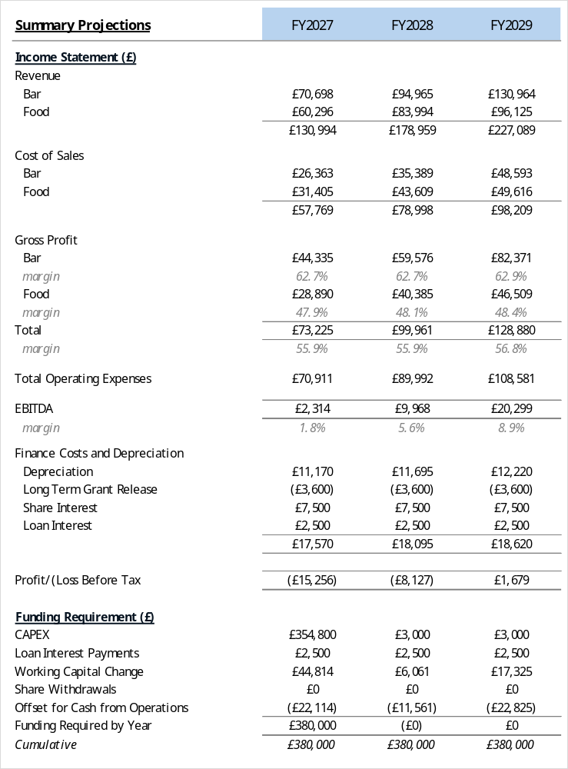
In Chart 1 above, FY27 projections currently indicate that after a slow ramp up, the pub will finally generate adequate revenue to post a monthly EBITDA profit of £125 in Month 5. However, as at the end of Month 4 there will be an accumulated EBITDA loss of £10,267.
The revenue streams have been built up using projected unit sales of beers and spirits at average prices (CBS assumed four different beers in varying volumes) with the direct costs based on supplier pricing. Food projections have been based on estimated covers at an average price. The average selling prices applied in each year are detailed below in Chart 3. These projections do NOT include any potential revenue derived from other income streams such as events or merchandising as referenced earlier in this plan.
The gross profit margins of 62.7% on bar and 47.9% on food, which result in a blended 55.9% have been assumed to be materially similar in FY28 and FY29.
Year on Year (YOY) growth at a revenue level is projected at 36.6% FY28 v FY27 but only 26.9% FY29 v FY28. Given the slow ramp up in FY27 and subsequent relatively low base, this apparent anomaly is not unexpected, additionally, if we look at the 3rd quarter average monthly revenue of FY27 and annualise for FY28 the projected outcome would represent a growth rate of only 18.2%.
Fleurets in Section 4.1 above indicated that the turnover, some years ago, was £190,000 with a 56% gross margin, so against those figures the above projections of revenue or margin look reasonable. Assuming minor growth and the impact of inflation it would be reasonable to assume that that turnover would be above £200,000 had that particular operator remained in place.
Concerning the increase in operating costs in FY28 v FY27, that is reflective of the implications of hiring part-time bar staff to supplement management and volunteers. There is an assumption that volunteer fatigue may creep in and it would therefore be unwise not to factor in costs for needed staff. Of the 26.9% increase of £19,081, these increased staffing costs account for £16,214; 85% of the increase. Clearly, the CBS will seek to ensure volunteer commitment remains high to reduce this increase as much as possible.
In terms of the FY29 v FY28 operating costs increase of £18,589, increasing part time staff costs account for £11,381; 61% of the increase, with the balance of the uptick being attributable to rising costs across the board.
Chart 1 indicates that the pub can generate a potential positive operating cashflow through achieving its FY27 target with a break-even revenue of c£127,000 assuming the 55.9% blended margin is achieved.
Depreciation - This is calculated in accordance with the CBS policies. All depreciation is straight line rather than reducing balance:
- Buildings – 2% per annum.
- Building improvements – 2% per annum.
- Kitchen and Electronic Equipment – 20% per annum.
- Furniture – 20% per annum.
Long Term Grant Release – The assumed £180,000 of grant receipts has been allocated against the purchase of the building and accordingly is being released over the same period as this is being depreciated (see comment above), namely fifty years.
Share Interest – Under the CBS shares will attract interest annually at 1% above Bank of England Base Rate, capped at 5%. In these projections the liability has been calculated at this maximum rate. Payment of share interest will commence in Year 4.
Loan Interest – It is assumed that part of the funds will be raised via a loan with the interest calculated at 5% per annum. This interest is assumed to be being paid monthly. The BP assumes no capital repayments are made in Years 1 to 5 – see 11.1 above.
Funding Requirement – This indicates a total of £380,000 is required for the purchase, refurbishment and operation of the Cottage Tavern.
Chart 2
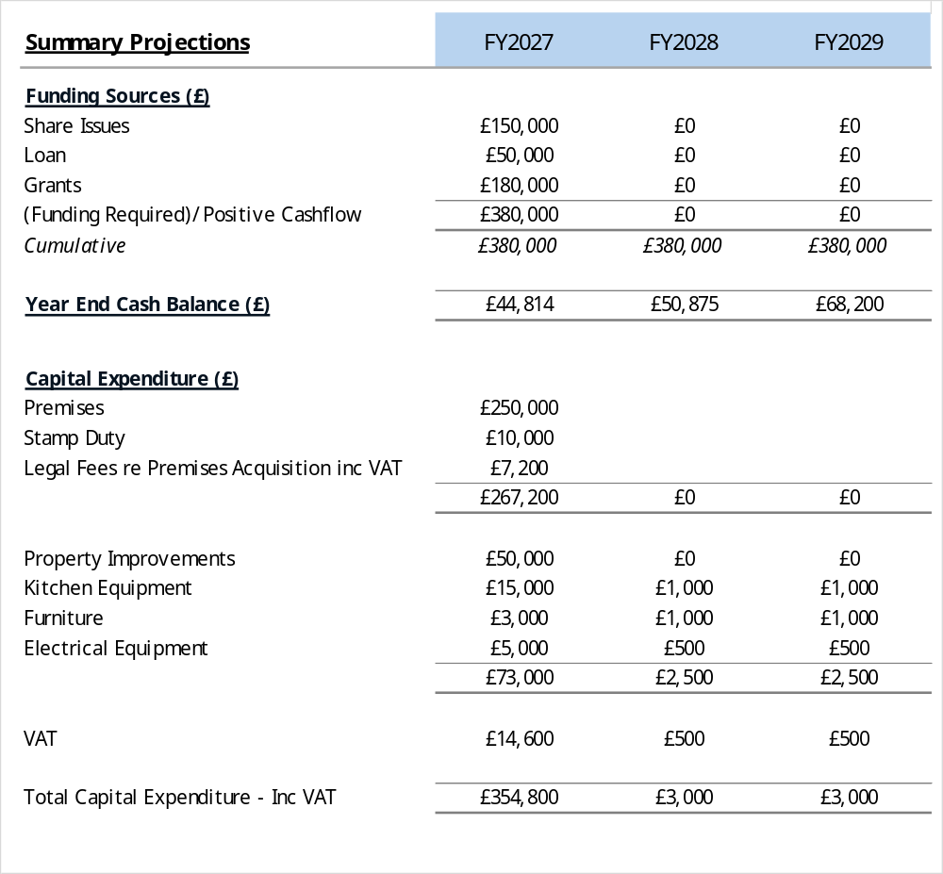
Chart 2 details the total funding required, and its sources, split between shares, grants and loans. Note – at present the CBS preference is to seek only one loan rather than multiple ones.
As you can see the projections indicate that after the initial fund raising in Year 1 it is assumed no additional monies will be required.
The principal cash outlay is in respect of the premises, currently projected at £260,000 including stamp duty plus £6,000 for legal and other professional fees. Clearly if the purchase price falls below £250,000, the stamp duty will reduce significantly but at this stage of the project that cannot be assumed to happen.
In terms of the remaining capital expenditure identified in Chart 2, this is based on best estimates of what will need to be spent to create the pub environment that will meet the community’s needs. These amounts have been significantly reduced to reflect a practical approach to the requirements. Amounts in FY 28 and FY29 are placeholders to enable upgrading any initial acquisition or alterations after a period of operation and will be only actioned where operating cashflows allow.

Chart 3
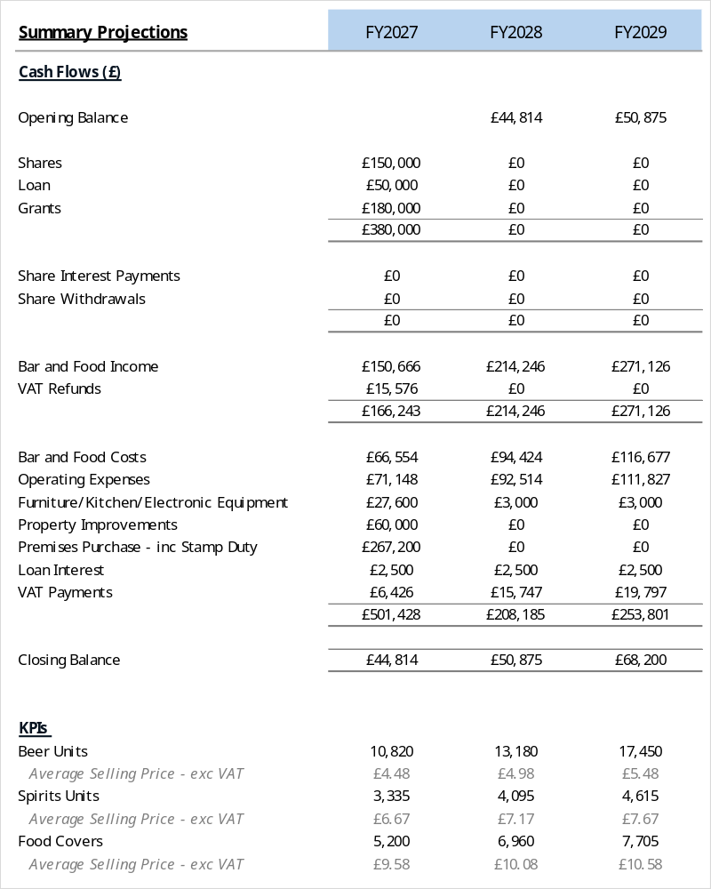
Chart 3 details three years cashflow projections, at a summary, level assuming that the full funding is acquired to the total of £380,000 – see Chart 2. The cashflows have been prepared on standard accounting bases with assumptions made as to average receipt and payment days. For reference all of the assumptions underpinning the detailed Excel financial projections, with the Charts contained herein being extracts from, are included in the attached Appendices.
VAT Refunds and Payments represent the amounts paid to HMRC in the year in question. The refund in FY27 primarily arises as a result of the recovery of input VAT on the renovations versus reduced output VAT arising from a slow build up in revenue. The projections assume quarterly VAT returns settled in the month following a normal VAT quarter. After an initial refund return it is expected that the CBS will be in a quarterly VAT payment cycle.
Key Performance Indicator (KPI) data discloses the average selling price of the revenue streams. The Food Covers average is impacted by the number of covers attributable to operating a coffee shop service. In Year 1 it is assumed 1,205 “coffee and cake” covers at an average sale price of £5.83.
Chart 4
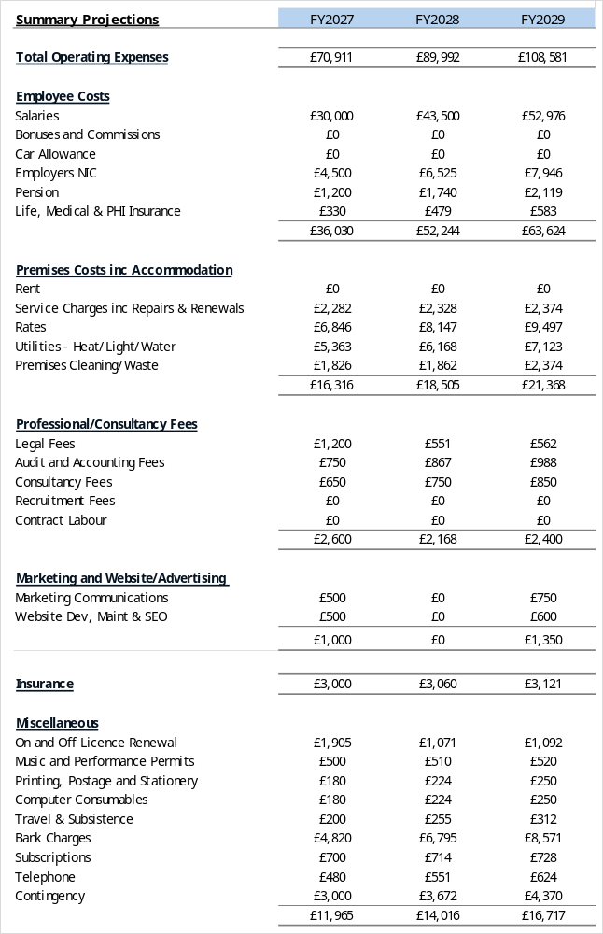
Chart 4 discloses detailed operating expenses from FY27 to FY29 see the comments referenced on Chart 1 re specific cost lines. Contingency costs are a catch all for unexpected expenditure.
Employee Costs are calculated applying appropriate taxes and offering staff adequate benefits.

Chart 5
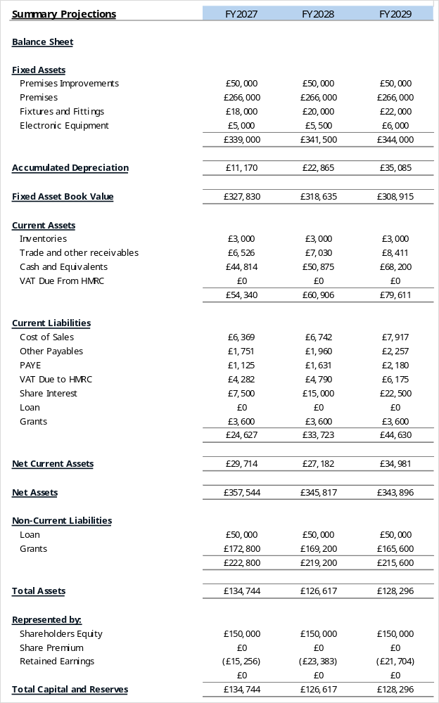

Chart 5 discloses FY27 to FY29 balance sheets for the CBS.
Fixed Assets – These values are original cost.
Accumulated Depreciation – All of the assets are being depreciated in accordance with CBS policies – see notes on Chart 1.
Fixed Asset Book Value – The aggregated value remaining of the assets after costs have been reduced by the calculated attributable depreciation.
Stock has been fixed at £3,000 throughout the period for simplicity, it is recognised that this may need to rise but not materially.
Trade and Other Receivables – CBS has assumed there may be credit card delays in funds received.
VAT - Returns made quarterly; payment of the calculated liability is made in the month following.
Cost of Sales – Assumes wet and dry materials may be on some form of credit and therefore timing of payment is delayed. Note, this amount is an offset for the deferred cash receipts detailed earlier.
Share Interest – See note on Chart 1.
Loan – It is assumed this will be long term or at least beyond the five years of this business plan.
Grants – See note on Chart 1. Is being released over fifty years.
Share Capital – There are no share withdrawals in the first three years.

Detailed monthly Profit and Loss, Balance Sheets and Cashflows have been prepared for FY27 to FY29 and are included in Appendix 6.

Chart 6

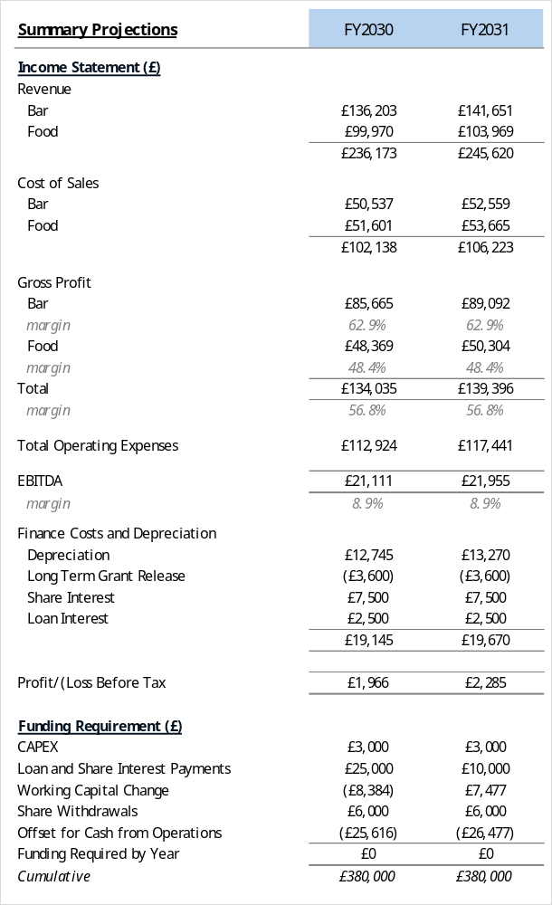

For FY30 and FY31 these schedules have been prepared at a high-level, extrapolating forward the positions reached at the end of FY29.

In respect of FY30 and FY31, the principal assumption underlying each year, is that revenue and cost growth will be only 4% but that this inherently incorporates a 3% inflation rate in each year, Essentially little more than 1% growth in the volume of beer and spirits and food covers detailed in Chart 8 below.

Chart 7

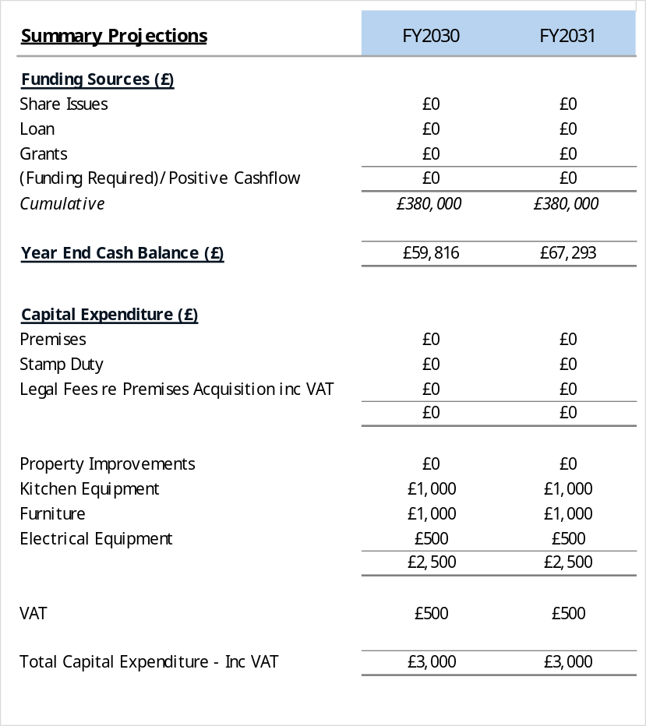

It is assumed there will be minimal need for capital expenditure of a material nature.

Given the trading position there is no need identified at this stage for additional external funding.

Chart 8

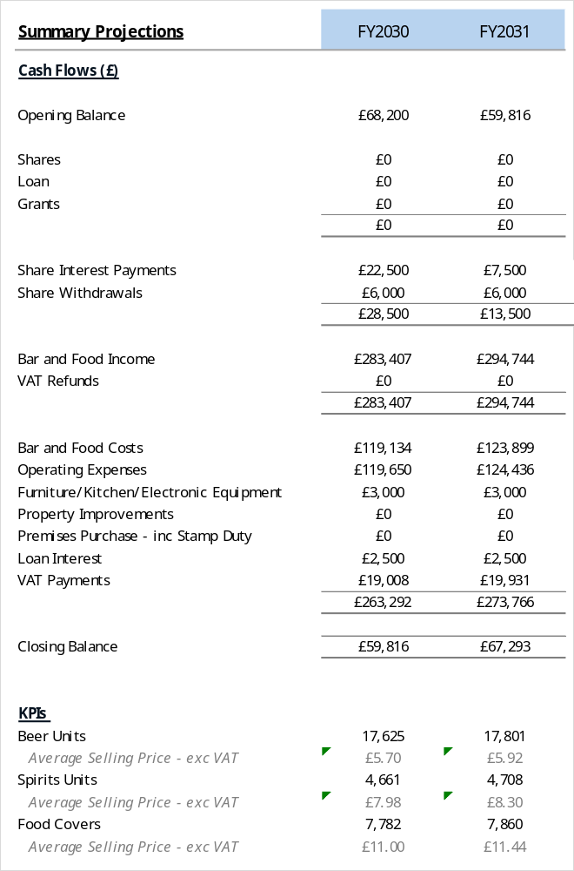

Share Interest Payments – This reflects payment of Year 1 to Year 3 accrued interest. Note payment will be made only at the Board’s discretion.

Share Withdrawals – From FY30 onwards the CBS will look to offer share withdrawals to members up to a maximum of 4% of the original share capital; in this model £6,000 per annum. Where applications are made for amounts exceeding this figure CBS may reduce the amount paid to an individual proportionally.

As stated earlier, FY30 and FY31 assume minimal growth in volumes of alcohol or number of food covers.

Chart 9

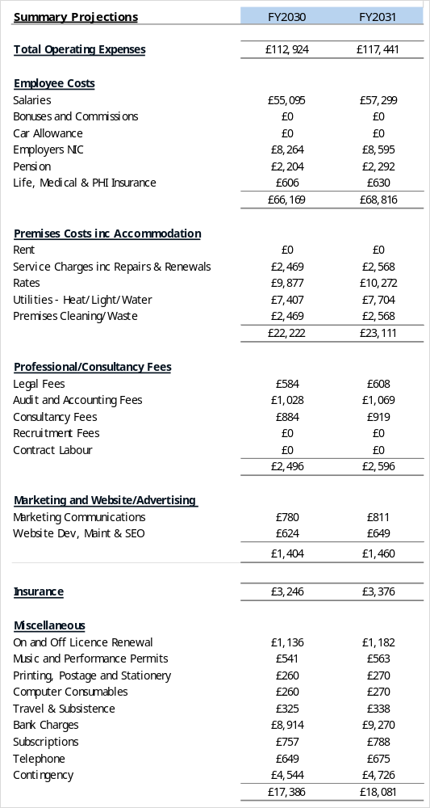

No material observations to make.

The costs have been extrapolated from the detailed costs in FY29.

Chart 10

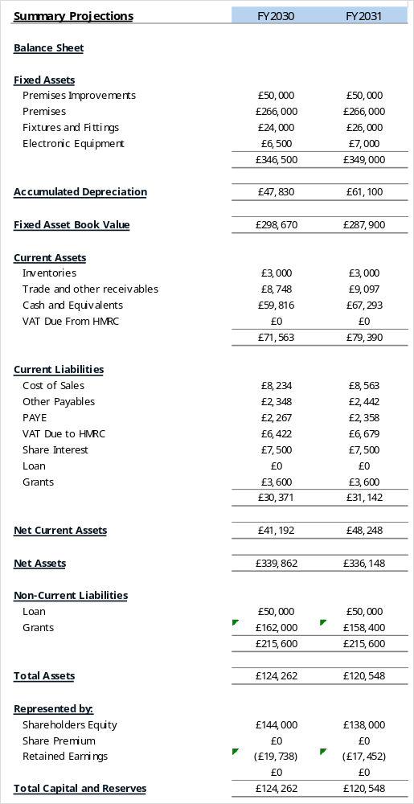

Overall, FY30 and FY31 indicate continued cash generation from operating the pub even in the context of low growth.

Additionally, the cash position at the end of FY30 of £59,816 is after making payment of three years accrued Share Interest to shareholders and the FY31 balance of £67,293 are after paying Shareholder Interest of £7,500. Note, if the Share Withdrawal in FY30 of £6,000 actually occurs the FY31 Share Interest payment will be reduced to £7,200.

There are no additional comments on the Balance Sheet not addressed in earlier comments.

Chart 11

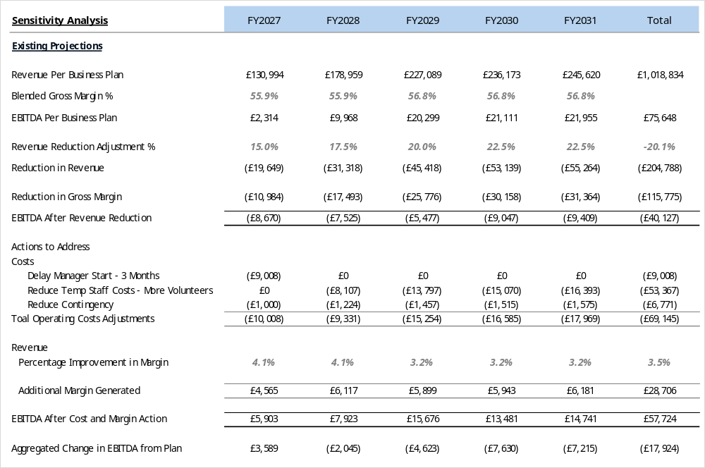

The above Chart examines the implication of reducing the Business Plan projected revenue numbers over five years.

In addition, the CBS has examined actions to be taken as a means to offset such an impact both at a cost and gross margin level.

It is our opinion that the blended margin used in our projections is on the low side. In comparisons with other pubs we have examined we are potentially 7% to 12.5% below that of other operations. However, we believe that as of preparing our financial projections we prefer to remain cautious but clearly there is an attainable opportunity to improve the gross margin, but our analysis above has only assumed a small increase to offset the modelled revenue reductions.

12. Risks and Mitigation

Risk | Mitigation
Insufficient trade | Strong community engagement, flexible offer
Rising costs | Energy efficiency, pricing review
Management failure | Robust recruitment and oversight
Key management committee member or manager/tenant leaving, especially at short notice | Personal license held by a member of the management group.
Insufficient funds via the share offer and/or unsuccessful grant application. | Loan opportunities taken up
Share withdrawal pressure | Board-controlled withdrawal policy

13. Implementation Timeline
- Marketing activity, valuation and negotiation for final purchase price – to 26.07.26
- Community mobilisation and share offer – opening 29.06.26
- Acquisition – 26.07.26 to 26.10.26
- Refurbishment – 26.10.26 to 23.12.26
- Recruitment – 01.08.26 to 23.12.26
- Opening - 30.12.26

14. Conclusion
Acquisition of the Cottage Tavern under the (CBS) model, does not provide for a private exit strategy. Consequently, the village pub will be held in community ownership for the long term in a resilient, inclusive and sustainable solution that protects a vital community asset for present and future generations.
The asset lock ensures that the pub cannot be sold for private gain with any surplus assets being retained for community benefit. Any generated surpluses will be reinvested in improving the pub and its facilities, expanding community use, strengthening financial resilience and supporting other local initiatives that benefit the community of Ashorne and Newbold Pacey as a whole.
Ashorne’s village pub has been run successfully in recent years and a model that includes the needs of the community, as well as making use of the location, local clubs and the attractiveness of a rural village for visitors has been thoroughly considered. The management of the Cottage Tavern with an individual manager supported by staff and volunteers and governed by a management committee will ensure the successful running of the pub for the years ahead to the ultimate benefit of the local community.

Over many decades, The Cottage Tavern has served as far more than a place to eat and drink. It has additionally been a setting for conversation, celebration, mutual support, and everyday social connection, helping to shape Ashorne’s identity as a close-knit rural community.

In a village with limited communal spaces, its role in bringing people together across ages and backgrounds is vital.

Appendices (in separate document)
Detailed supplementary appendices are contained in a separate document.

