Business Plan - Appendices

The Cottage Tavern Community Pub Limited
(FCA registered as a Community Benefit Society – 9723)

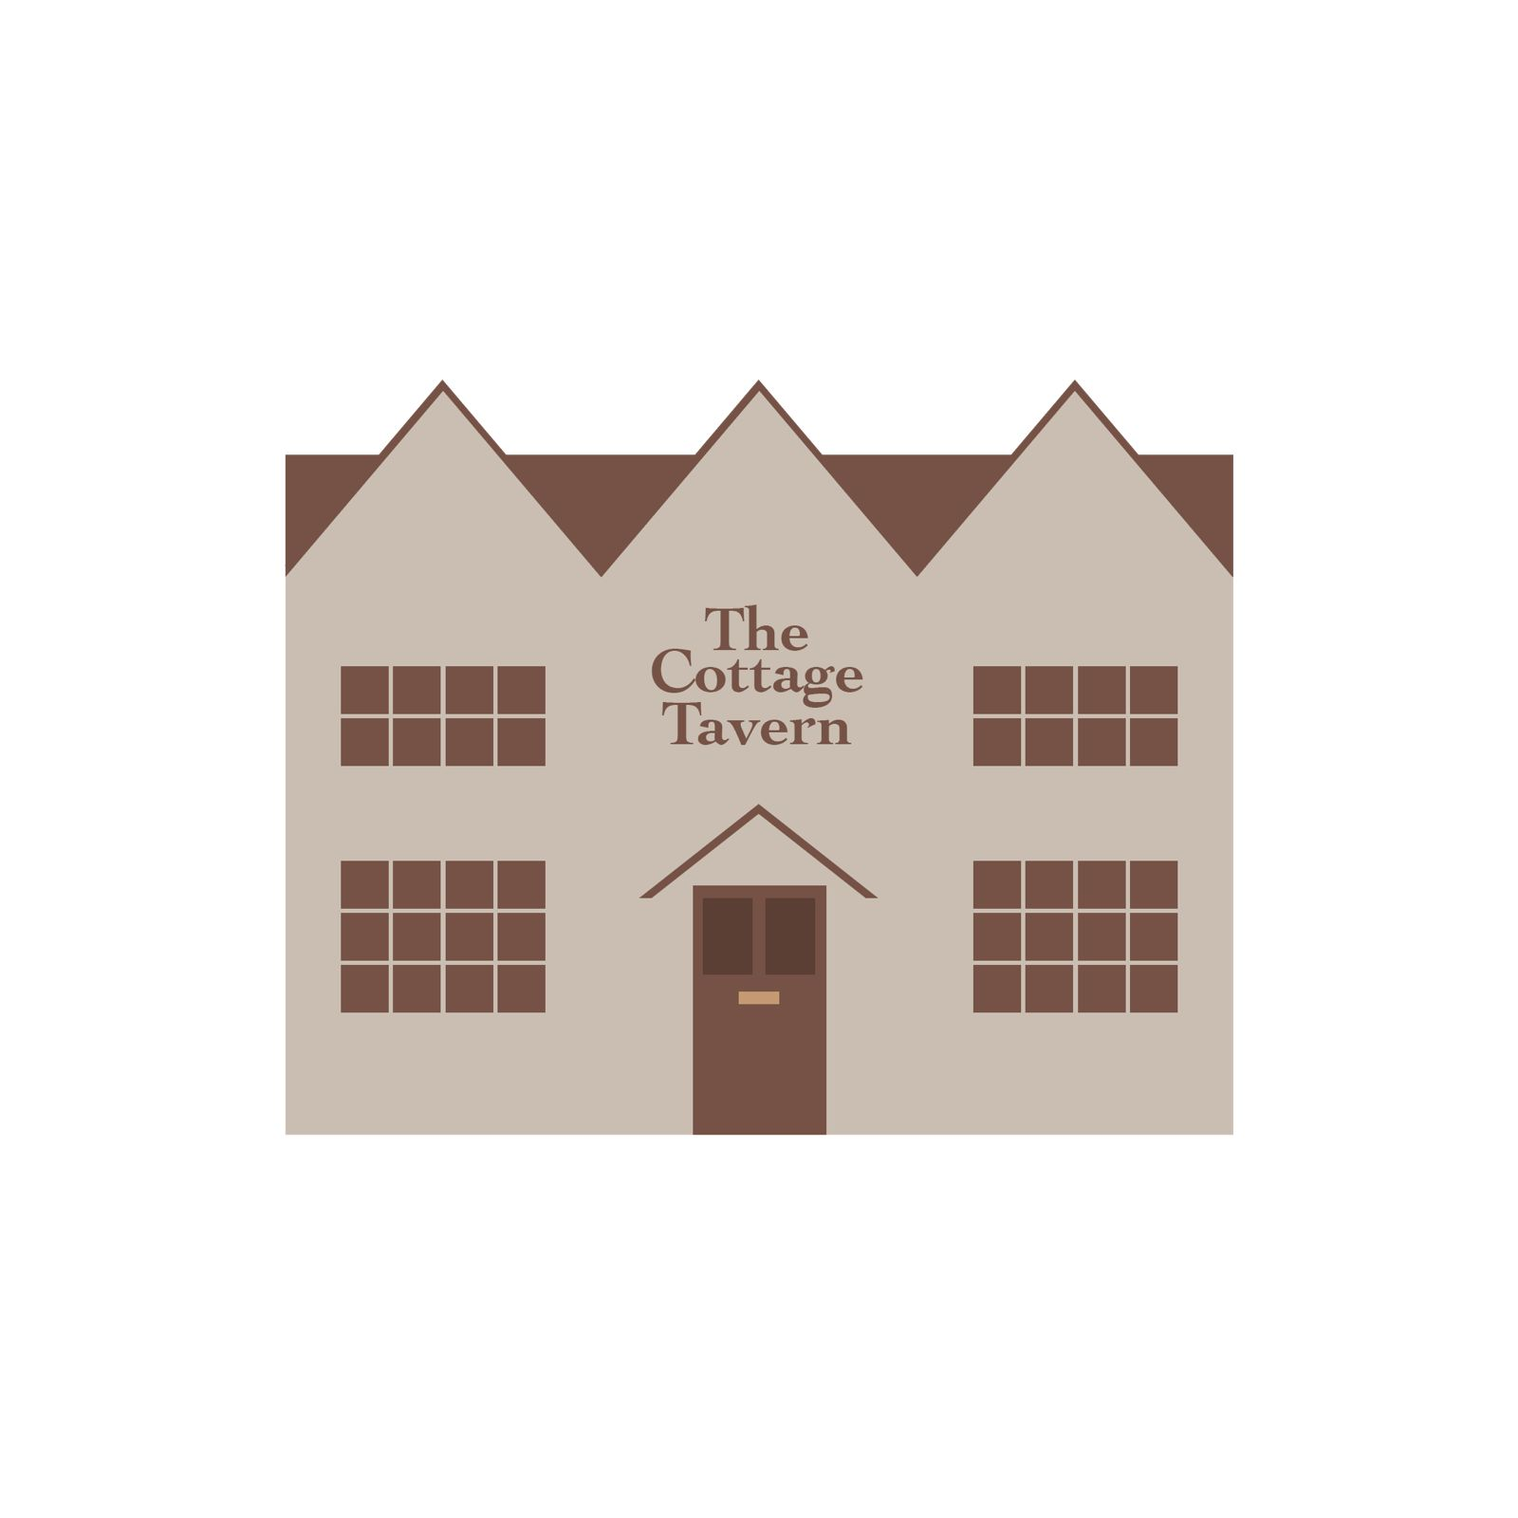

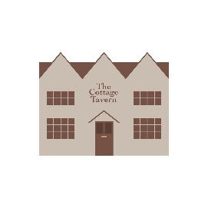
Appendix 1

Rules for Community Benefit Society:

The Cottage Tavern Community Benefit Society Limited
Registered under the Co-operative and Community Benefit Societies Act 2014

1. Name
The name of the society shall be The Cottage Tavern Community Benefit Society Limited (“the Society”).

2. Registered Office
The registered office of the Society shall be situated in England and Wales.

3. Objects
The Society is established for the benefit of the community and not for the private benefit of its members.
Its objects are:
3.1 To acquire, own, lease, develop, manage, and operate a public house as a community-owned asset.
3.2 To provide a sustainable public house that serves as a focal point for community life, social interaction, and inclusion.
3.3 To promote social wellbeing, community cohesion, and rural or neighbourhood regeneration.
3.4 To provide facilities for recreation, meetings, education, and cultural activities for the benefit of the community.
3.5 To apply all surpluses and assets for the benefit of the community served by the Society.

4. Powers
The Society shall have all the powers of a natural person necessary to achieve its objects, including (but not limited to) the power to:
4.1 Raise funds by the issue of withdrawable community shares or loan stock.
4.2 Purchase, lease, hold, manage, improve, and dispose of land or buildings.
4.3 Employ staff and engage contractors or volunteers.
4.4 Sell food, drink, and related services and hold any licences required for these purposes.
4.5 Enter into partnerships or agreements consistent with the Society’s objects.
4.6 Invest surplus funds in lawful and prudent investments approved by the Board, subject to any limits set by members in general meeting.

5. Membership

5.1 Eligibility
Membership of the Society is open to individuals, societies, companies, and other organisations who:
- support the objects of the Society;
- apply for membership in a manner approved by the Board; and
- hold at least one share in the Society.

5.2 Member Register
The Society shall maintain a register of members in accordance with the Act.

5.3 Termination of Membership
Membership shall cease on:
- withdrawal of all shares;
- death (for individuals), bankruptcy, or sequestration;
- dissolution (for organisations); or
- expulsion for conduct detrimental to the Society, subject to a fair process and right of appeal.

6. Death or Insolvency of a Member
On death, bankruptcy, or sequestration, the Board shall pay the nominal value of the member’s shares to their personal representatives, trustees, or nominees, subject to the provisions of the Act.

7. Share Capital
7.1 The Society shall have withdrawable share capital.
7.2 The minimum shareholding shall be £250, and the maximum shareholding shall not exceed the statutory limit.
7.3 Shares are not transferable.
7.4 The Board may refuse an application for shares where it considers this to be in the best interests of the Society.

8. Withdrawal of Shares
8.1 Shares may be withdrawn only at the discretion of the Board.
8.2 The Board may suspend withdrawals where it considers that the financial stability of the Society would be threatened.
8.3 Withdrawals shall be paid at face value only and shall not confer any right to capital appreciation.

9. Interest on Share Capital
9.1 The Society may pay interest on share capital only where the Board considers it necessary to attract and retain the capital required to further the Society’s objects.
9.2 Interest shall be limited to the lowest rate sufficient for this purpose and shall not be speculative.
9.3 The rate of interest shall be recommended by the Board and approved by members at a general meeting.

10. Application of Surplus and Asset Lock
10.1 The Society shall not distribute any surplus to members except for limited interest on share capital.
10.2 Any surplus shall be applied solely to:
- furthering the objects of the Society; or
- supporting community benefit activities consistent with those objects.
10.3 The assets of the Society shall be subject to an asset lock.

11. Loans and Borrowings
11.1 The Society may borrow money and contract loans from members or others, subject to the provisions of the Act.
11.2 The Board shall determine the terms, conditions, security, and repayment arrangements for all borrowing.
11.3 Total borrowings shall not exceed any limits set by members in general meeting.
11.4 The Society shall not accept money on deposit within the meaning of the Act.

12. General Meetings
12.1 The Society shall hold an Annual General Meeting in each calendar year.
12.2 Each member shall have one vote, regardless of the number of shares held.
12.3 Voting may take place in person, by proxy, or electronically where permitted by the Board.

13. Board of Directors

13.1 Role of the Board
The Board shall manage the business of the Society and ensure it is carried out in accordance with these rules and for community benefit.

13.2 Composition
- The Board shall consist of not fewer than 3 and not more than 12 directors.
- All directors must be members of the Society.

13.3 Election and Retirement
- Directors shall be elected by members at the AGM.
- Directors shall retire by rotation and may stand for re-election.

14. Conflicts of Interest
14.1 Directors must declare any personal or financial interest in any matter.
14.2 A director with a conflict shall not vote on the matter concerned.
14.3 The Board shall maintain a register of directors’ interests.

15. Committees, Managers and Officers
15.1 The Board may establish committees and determine their powers, duties, and duration.
15.2 The Board may appoint and remove managers and officers (paid or unpaid) and determine their terms and duties.
15.3 Any remuneration shall be reasonable and approved by the Board. Directors shall not receive remuneration for acting as directors except reimbursement of reasonable expenses unless permitted by law.
15.4 Delegation does not relieve the Board of collective responsibility.

16. Management of the Public House
16.1 The Board may appoint a paid manager, tenant, or management committee to operate the public house.
16.2 The Board retains ultimate responsibility for compliance, finances, and community benefit.

17. Accounts and Records
17.1 The Society shall keep proper accounting records.
17.2 Annual accounts and reports shall be presented to members at the AGM.
17.3 An auditor or independent examiner shall be appointed where required by law.

18. Common Seal (Optional)
If the Society has a common seal, its use shall be authorised by a Board resolution and attested by at least one director.

19. Amendments to Rules
19.1 These rules may be amended by special resolution of members.
19.2 No amendment shall be valid if it would undermine the community benefit purpose or asset lock.
19.3 All amendments must be registered with the Financial Conduct Authority.

20. Dissolution
20.1 The Society may be dissolved by special resolution.
20.2 After satisfaction of all liabilities, remaining assets shall be transferred to another asset-locked community benefit society or a charity with similar objects.

21. Interpretation
In these rules:
- “the Act” means the Co-operative and Community Benefit Societies Act 2014;
- “the Board” means the Board of Directors of the Society.

Appendix 2 Community engagement consultation 2025 – 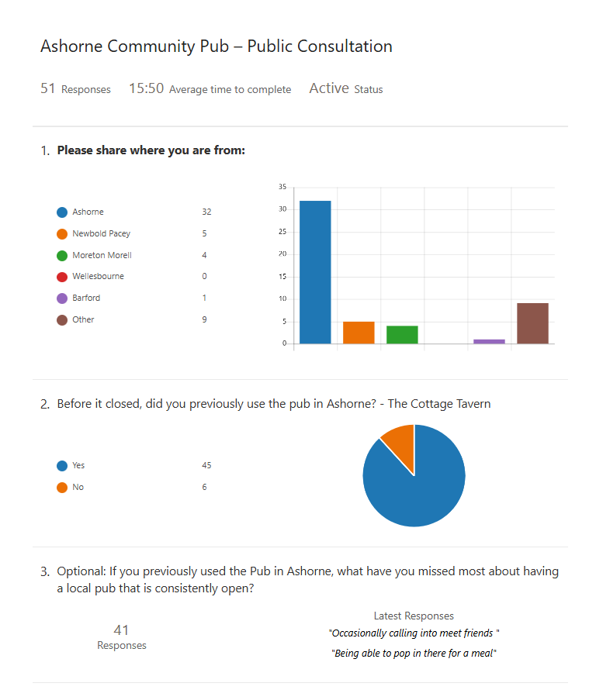
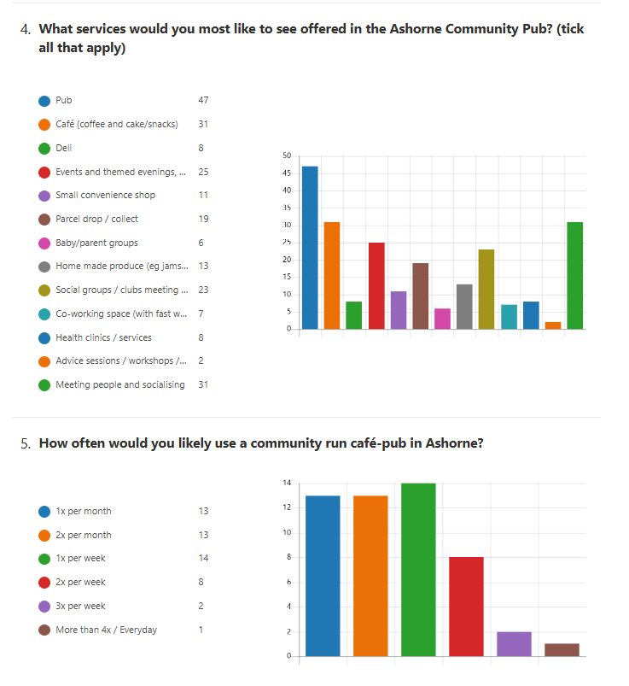
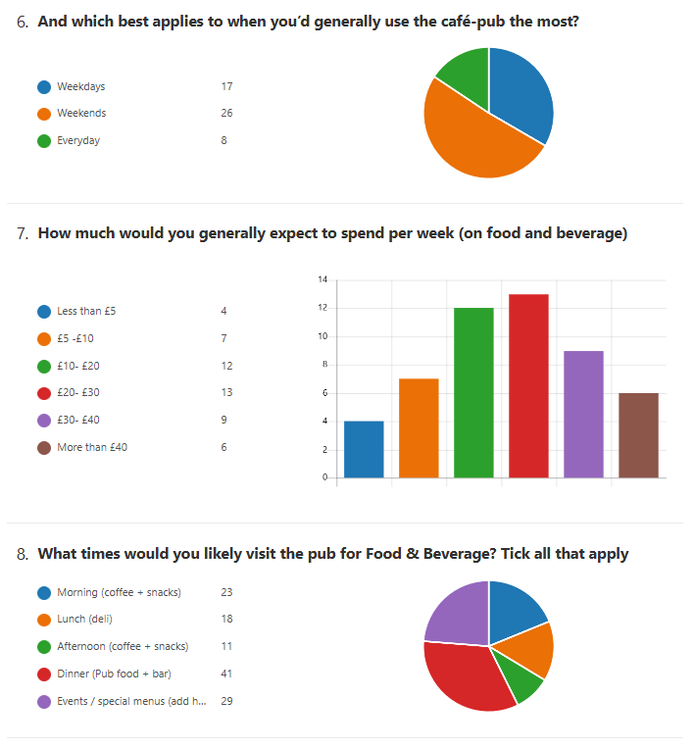
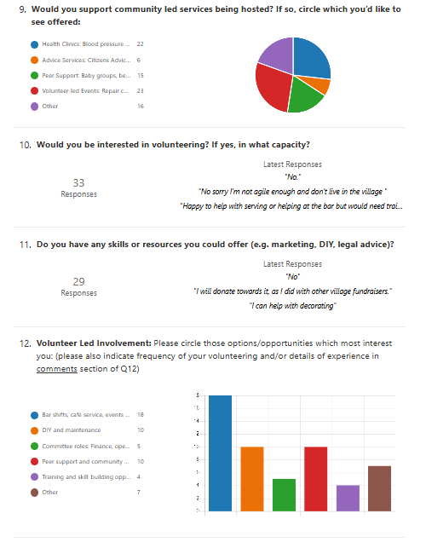
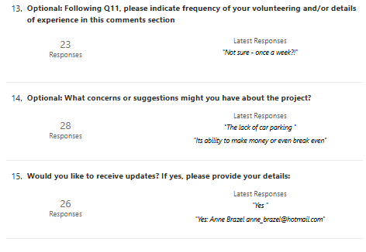

Qualitative responses

Answers to optional questions
Q - If you previously used the Pub in Ashorne, what have you missed most about having a local pub that is consistently open?
42 responses.

ID | Name | Responses
1 | anonymous | Socialising with local people; quality ales; authentic pub grub.
2 | anonymous | Meeting friends from Ashorne to have a good drink without the need to drive.
3 | anonymous | Seeing the local people, having that sense of community within the village to socialise, celebrate occasions and reminisce.
4 | anonymous | Getting together with neighbours.
5 | anonymous | The social, the food (thinking back to the Lesley days), the reason for a walk into the village.
6 | anonymous | Social events.
7 | anonymous | Company.
8 | anonymous | Dinner out with family, either a quick, affordable meal during the week or a get together on the weekend. Also, a coffee on the weekend after a walk. And of course, catching up with the neighbours.
9 | anonymous | Definitely the woodburners in the dark winter days, seeing familiar faces, the odd pint, and a nice fish pie.
10 | anonymous | The company and the chance of an informal meal at short notice.
11 | anonymous | Nothing; The food hadn't been great for some time. The atmosphere was cold & uninviting. Parking for visitors has always been "Difficult".
12 | anonymous | A nice cosy local pub I can walk to.
13 | anonymous | The social interaction.
14 | anonymous | Good food.
15 | anonymous | Nothing. The food was terrible, awful atmosphere, unwelcoming, tired, dated, dreadful lighting, cold and totally dull.
16 | anonymous | Opportunity to grab a meal. Meet with locals and chat.
17 | anonymous | Local place to drink without driving. Easy place to go out for food. Meeting friends. Taking visitors out.
18 | anonymous | The social aspect of catching up with village people. Friends joining us for drinks / food.
19 | anonymous | Meeting people for a drink.
20 | anonymous | Convenience and socialising.
21 | anonymous | Cricket club has missed being able to meet there and have drinks post-match and to have our fundraising events there.
22 | anonymous
23 | anonymous | Nothing that comes to mind. It wasn't the greatest.
24 | anonymous | Having a reasonable place to go for a meal locally.
25 | anonymous | Being able to walk down for a drink / meal on the spur of the moment.
26 | anonymous | Socialising.
27 | anonymous | A place to meet up and dine.
28 | anonymous | Nothing.
29 | anonymous | Stopping on a walk or a Bike ride.
30 | anonymous | Didn’t use the pub often enough to miss it despite enjoying the environment when we did visit.
31 | anonymous | Nice local place for a drink and social hub.
32 | anonymous | The ability to be able to socialise spontaneously - no prior arrangements needed, just head to the pub for some company and a chat - especially important if you go out on your own. Used to enjoy being able to decide to go to the pub for an evening meal at a reasonable price, with good wholesome food, in a friendly environment.
33 | anonymous | Having local village pubs within walking distance giving a walk and a destination.
34 | anonymous | Can’t be bothered to cook simple food at modest prices.
35 | anonymous | The great food, nice atmosphere, and somewhere different to go.
36 | anonymous | Good selection of real ale and good food.
37 | anonymous | Proper pub food, nothing fancy, just good home cooked meals and a reasonable price with friendly staff and a nice selection of drinks.
38 | anonymous | A perfect calling point in a pleasant village on my regular walks.
39 | anonymous | Enjoying a drink in a quiet genuine village pub.
40 | anonymous | Meeting villagers and food.
41 | anonymous | Being able to pop in there for a meal.
42 | anonymous | Occasionally calling in to meet friends.

Optional: What concerns or suggestions might you have about the project?
28 responses
ID | Name | Responses
1 | anonymous | Lack of locals actually using the place.
2 | anonymous | Women’s toilets smelt of possibly blocked drains.
3 | anonymous | I think you might be being too ambitious with everything you would like to offer.
4 | anonymous | We need to consider parking, is there alternative space we can use?
5 | anonymous | As Ashorne is a small village it’s hard to support the pub enough without attracting people from outside the village. The reach needs to expand to Newbold Pacey and Wellesbourne etc. When I mention the pub to friends outside the village they usually mention the lack of parking or are unsure if the pub is open or not.
6 | anonymous | I absolutely love this. Let's do it. I'm sure it'll be fine.
7 | anonymous | Has there been any investigation into vermin, sale of (the adjacent) "Poo Cottage" fell through after a survey? Does anyone know what facilities (Fridges/Freezers & approved food storage) are remaining for cooking fresh food or would it just be a "microwave warm up" without significant investment? Doubt it would be viable as the footfall would be too small without a carpark, Lighthorne is a much larger village, providing a substantially larger customer base. Their pub, (already offering similar facilities to those suggested/listed & also with a viable carpark) has recently closed down. Wouldn't development of the Cottage Tavern adversely affect both the Village Hut in Ashorne & the Black Horse Pub in Moreton Morrell?
8 | anonymous | Limited parking may cause issues
9 | anonymous | None
10 | anonymous | There is not enough passing traffic and very limited parking. The village hall already provides facilities for social events, meetings, and parties etc. The Antelope and Black Horse are well established businesses, both with plenty of character and charm, unlike The Cottage Tavern. There is also the wonderful café in Lighthorne which attracts an awful lot of people so it is doubtful that a small one in a hamlet, will attract much business and probably not much repeat business. We would not be interested in investing in something which is very unlikely to be successful taking into account the previous history of The Cottage Tavern, lack of a car park and not enough locals to make it viable.
11 | anonymous | Only a few locals regularly used the pub before it closed, and this makes reopening financially difficult. Maybe revamping the accommodation and renting could be an option, but not many people would want to live above a pub. Clubs etc. already have use of the village hall, so have to take care not to target the same clubs etc. otherwise both premises become less viable. Making more of the beer garden - demolish the garage to extend the beer garden could be good. Village BBQ could then take place here. Parking is a limitation, agree with the village hall use of the car park for a limited number of spaces. Someone probably needs overall management responsibility for the pub, which is a major undertaking for a volunteer.
12 | anonymous | Lack of community support. Lack of skills and enthusiasm from the tenants. Difficulty recruiting a landlord.
13 | anonymous | No concerns.
14 | anonymous | Getting stuck into irrelevant detail/plans that is some way down the line rather than focusing on securing the pub.
15 | anonymous | It needs the whole village to visit regularly.
16 | anonymous | The village hut provides most of what you propose for The Cottage Tavern.
17 | anonymous | Taking away from Ashorne Village hall. Not a great plan. Keep it as a pub or not at all. We are very doubtful this will be successful however you use the building. Simply not enough locals and not a great spot for outsiders due to not having a car park, which the village hall has.
18 | anonymous | That it is a huge investment and it would be better to lease the pub on a short term favourable rent to see how it goes before committing to buying it. I am also wondering how such a small village will raise the money to buy the pub, decorate, and furnish it.
19 | anonymous | I fear the absence of a garden or car parking will limit the appeal of the pub to those outside of Ashorne.
20 | anonymous | Village pessimists and negativity. It puts me off going to the pub and will hinder gaining support.
21 | anonymous | The meeting held on the19th was excellent, just the right agenda and length. Ashorne in terms of the Village Hut committee has a great track record for fund raising and I am confident that there is a nucleus of local people who can make the community pub work. I have concerns on two issues which I did not wish to raise last night as I did not want to dampen the enthusiasm that was present. The parking area adjacent to the Village Hut can only be used in relation to events held at the hut. Particularly on a regular basis. There are issues surrounding the use and ownership of this area that the Trustees are wrestling with at the moment, the issues have rumbled on for many years, decades even but I do know that Pub parking is a nonstarter. My second observation is the drive to get the “best Price” for the Pub confirmed. I strongly council you to avoid this until you have more of your funding options clarified. You said in response to Willie Carrol “we know the price” , that is the asking price. Undoubtedly there is room for negotiation but at the moment you are not a credible purchaser. The agent and William are extremely unlikely to disclose the “buy it now price” to a group who are keen and enthusiastic but don’t have a plan. It’s not in their interest and to believe it is so naive. Wait a month or however long until you can show them that you have a plan to raise the purchase price and the support and commitment of a significant part of the community. A limited company is cheap to register, a management committee pretty well exists, get commitments to buy a deposit amount of shares and you have the bones of a credible purchaser. If it’s £400k or £350k is pretty academic in the scheme of things at the moment. It’s not the issue. Raising funding is. A dialogue with the agent and the owner is good but give them some details and an indication that you are serious and not just enthusiastic. I’ve been retired a while now but my commercial instincts where saying this is premature. Last point I have a copy of the last Census analysis for the Parish it has a great deal of demographic detail that may help support your fund raising. Let me know and I will get a copy to you.
22 | anonymous | Focus on smaller offering initially perhaps just pub and cafe etc. things to attract walkers and cyclists. Similar to black horse.
23 | anonymous | Support of village community is vital, as is consistency of opening to an agreed schedule of hours Suggestions: Perhaps there could be a day per month/fortnight, when mobile personal care technicians such as hairdresser, nail technician, reflexologist, chiropodist could attend (for a fee) and provide their services to the community on a prebooked basis? Live Music/jam sessions New Years Eve Celebrations Boxing Day brunch and even possibly Christmas Day lunch Quizzes Darts Dominoes and Crib teams playing from the Cottage Funeral wakes being offered and heavily publicised Ramblers Societies being contacted to offer lunches.
24 | anonymous | Clear decision making to get the pub reopened. Dangers of committee and having too many decision makers.
25 | anonymous | That the Ashorne and Newbold Pacey people support it.
26 | anonymous | By coincidence I very recently visited The Gate Hangs Well https://thegatehangswell.com/ in Carlton in Leicestershire. This lovely and seemingly very successful enterprise seems to be a model for the type of community operation (Pub+Cafe+ ) you are proposing for The Cottage Tavern so it would be well worth your while visiting them for ideas. Although I haven't visited The Cottage (yet!) as it has not been open when I was in the village I wish you all the best with your venture.
27 | anonymous | Its ability to make money or even break even.
28 | anonymous | The lack of car parking.

Appendix 3 Founding Members’ details

Paul Brazel:

Paul Brazel and his family have lived in the village since 2017 and throughout that period the pub has been a focal point for the community to come together; a place to meet the locals. Living literally next door, its closure has been keenly noted.

During his time in the village, he has been a Parish Councillor and for a period Chair of the Parish Council and recognised that this gave him insight into the needs of a small community such as ours where the pub is a key focal point.

As a Chartered Accountant by profession and CFO and CEO by activity, Paul has extensive financial and general business management experience, ranging from start-ups to multi-national technology operations and has been involved in raising funding for all sizes of operation at various stages of their development.

Paul's financial based roles have necessitated in depth understanding of accounting and business systems and controls, accurate cash flow projections and cost control. In addition, he is well versed in the vagaries of taxation be it VAT, PAYE or corporate taxes.

Paul says, "I am pleased to be engaged in this project to re-open the pub and restore the sadly missed heart of the community to the position it has held in the past".

Pete Elliott:

As a Founding Member, Pete Elliott brings both professional expertise and deep personal commitment to his role as a founding member of the Cottage Tavern Community Benefit Society. As the long-term director of a manufacturing company, he understands what it takes to run a sustainable enterprise and is motivated to use those skills to support a project that matters to the whole village. His strategic experience, combined with practical problem-solving, gives him a clear sense of how a community-owned pub can thrive.
Pete was a ‘regular’ at the Cottage Tavern and knows first-hand the sense of belonging it created. For him, the pub was never just a place to socialise; it was a vital part of village life. A chance conversation there even led to the early identification of a medical issue — a reminder of how important informal community spaces are for wellbeing. The closure of the pub weakened the very community spirit that first drew him to the village, strengthening his resolve to help restore it.
Pete’s love of the countryside is central to his involvement - he values Ashorne’s character and has consistently supported events at the church, village hall and on community walks, as well as helping protect the surrounding landscape. The Cottage Tavern, in his view, is an essential part of that wider ecosystem.
Alongside his professional and community commitments, Pete is a devoted family man and lifelong rugby enthusiast. The values he holds dear — teamwork, loyalty, and shared purpose — underpin his belief that the Cottage Tavern can once again bring people together and strengthen village life.

Kate Freeman:

Kate Freeman has lived in Ashorne for 13 years, having moved from a similarly rural village in another part of Warwickshire. She has been a member of the village hall committee for a number of years, as well as being involved in the local church and has been a regular user of the Cottage Tavern for social events and community connection.
Kate recognises the role that the Cottage Tavern has to play, not only in social support, but also in ensuring the physical and mental well-being of the residents of the village and other communities.
Kate works in her professional life to enable children and young people and their families to be adequately supported by local authority and health systems.
Kate is an experienced fundraiser and charity worker having set up a children's holiday organisation at the age of 19 years and ensured its funding for the next 10 years. Kate has also enabled funding to be available for the village halls in both her previous village and in Ashorne.
Kate’s family have already used the village pub until its closure and she very much misses seeing a light on outside the door and hearing the sound of singing, laughing and animated conversations that used to emit from the front door of the Cottage Tavern.

Greg Jones:

Having lived in the village since 1 September 1997, Greg and his family have benefited greatly from the relationships, support, and sense of community fostered through the pub. Over the years, this has given Greg a strong understanding of its importance as a social hub and the vital role it plays in bringing people together.

Professionally, as a former director of an independent financial adviser company, Greg has developed extensive experience in financial planning, business management, governance, and regulatory compliance. This includes budgeting, cash flow management, risk assessment, and strategic decision-making—skills that are directly relevant to ensuring the long-term sustainability and success of a community-owned pub.

In addition, his role required clear communication with clients, building trust, and explaining complex financial matters in an accessible way. These skills are equally valuable when engaging with shareholders, members, and the wider community.

Combining this professional background with Greg’s personal commitment to the village, he is well placed to contribute to the effective management, financial stability, and community focus of the society, chairing the volunteer management committee and helping to secure the pub as a thriving asset for future generations.

Greg says, “I am pleased to serve as a director of the community benefit society and to play a part in supporting its continued success for the benefit of our community.”

Helen Oakley:

Helen Oakley moved to Ashorne 3 days before Christmas in 1987 having purchased the freehold of the Cottage Tavern with her husband. The property needed considerable renovation which they undertook whilst continuing to trade and under their 10-year ownership the pub went from strength to strength.

Following the birth of their son, Helen and her husband sold the Cottage Tavern and moved to a property opposite, which they had converted to a dwelling. Helen says “Ashorne community is dear to my heart, and we remain in this house. I have always played a very active part in village life… I still captain the Cottage Tavern cribbage team, although we have to play from another venue due to the Cottage Tavern being closed.” Helen is also a member of the Ashorne Events Committee which organises social events for village residents on a regular basis

Professionally, for most of her life, Helen has been in the hospitality industry and has considerable experience in organising events and running hospitality businesses.

Helen says “My belief is that the Cottage Tavern is an essential asset to the village of Ashorne in combatting isolation and promoting village cohesion and community spirit. As part of the management committee of the CBS, I look forward to bringing to bear my years of experience once we open as a community venture.”

Dale Robinson:

Dale Robinson is the director of EquityOne Finance Ltd., where he has built and led the business for many years, gaining extensive experience in running and managing a successful enterprise within the property and finance sector.
Dale brings strong commercial awareness, leadership, and strategic oversight, developed through years of hands-on involvement in business operations, client relationships, and deal structuring. His experience provides a solid foundation for governance, financial discipline, and long-term sustainability.
He currently serves on the volunteer management group of The Cottage Tavern Community Benefit Society Limited, where he is contributing to the community initiative to acquire and reopen the Cottage Tavern in Ashorne. His involvement is driven by a commitment to protecting and enhancing local community assets, ensuring that the pub is secured as a long-term, community-owned facility for social, economic, and cultural benefit.
With strong local ties and a personal commitment to the area, Dale is passionate about bringing people together, supporting community cohesion, and delivering a sustainable future for the Cottage Tavern for the benefit of current and future generations.

Appendix 4 Staffing

Staffing & Back Office Model: Partnership Approach
- Core Paid Staff
Role | Hours | Notes
Pub Manager | Part-time (assumed one of a couple living in) | Oversees operations, staff, suppliers, compliance. Reports to the committee.
Cook | Part-time (assumed to be part of the couple living in) | Especially important if you’re running a café/deli. Could be job-shared.
Bar Staff | Volunteer led in the first year, transitioning to volunteer and part time staff, assumes volunteer fatigue begins after initial excitement begins to recede | Mix of paid and volunteer shifts. Paid staff cover peak hours.

2. Volunteer Roles
Role | Commitment | Notes
Bar Support | 1–2 shifts/month amongst villagers | Especially during quiet hours or events.
Events Coordinator | Flexible / many individuals (passion projects etc.) | Organises quiz nights, talks, or community events.
Maintenance Team | Ad hoc | Local tradespeople or DIYers for small repairs.
Marketing & Social Media | 2–4 hrs/week | Promotes events, share stories, updates.
Committee Members | Monthly meetings | Strategic oversight, fundraising, community liaison.

Appendix 5 Ashorne Census Data

- Most recent census data indicates:
  - 39% of households are identified as deprived in one or two dimensions.
  - 12% of households are headed by a lone parent.
  - 5% of households do not have access to a car or van.
  - 62% of over 16-year-olds (excluding full time students) are economically active.
  - 49% of working residents work mainly from home.
  - 71% of working residents work full time.
  - 4% of residents are long term unemployed.
  - Of those who are married or in a civil partnership, 64% have dependent children.
  - Of those who are cohabitating, 70% have no children.
  - The greatest proportion of households have 3 people in them (52%).
  - 82% of households have families under 65 years of age.

Appendix 6 Additional Financial Data

This appendix contains additional detailed financial data on a monthly basis for FY27 to FY29 of the Cottage Tavern’s operation in respect of the P&L account, Cashflows and Balance Sheets.

The core assumptions underpinning the financial projections, including inflation, salary increases if appropriate and associated timings, have also been included here for reference.

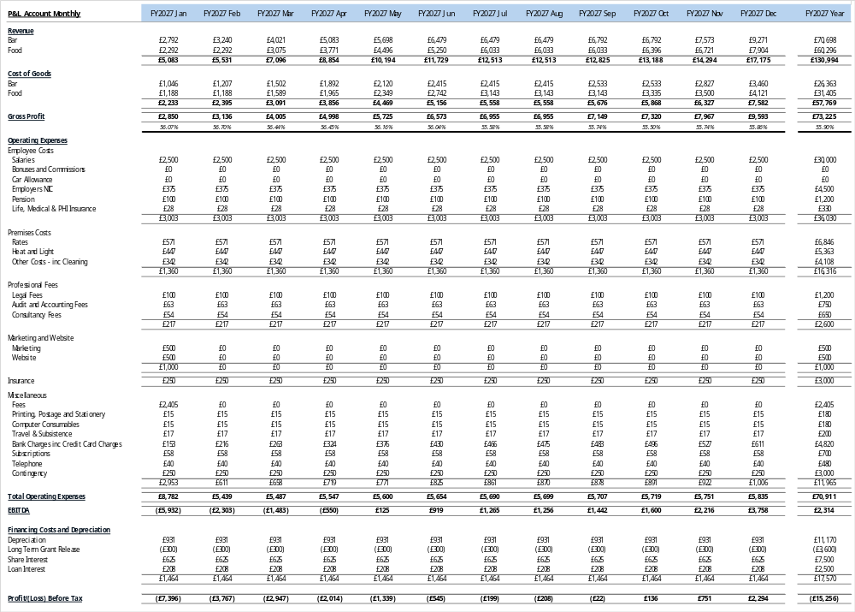
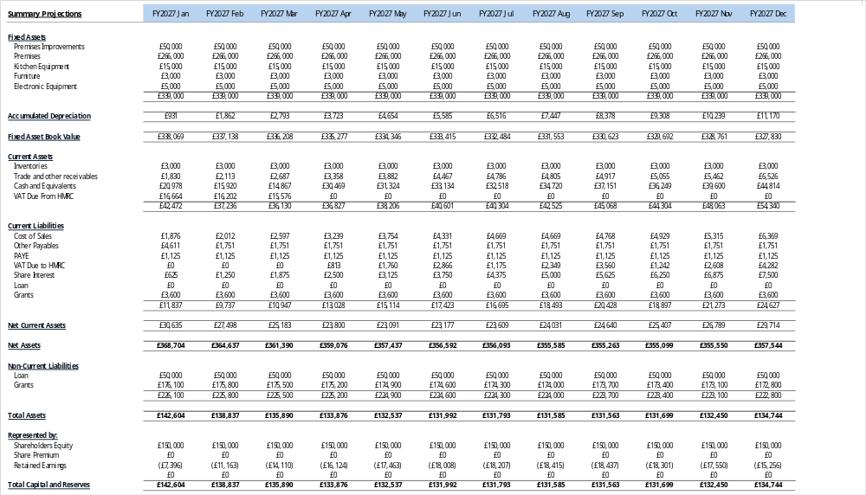

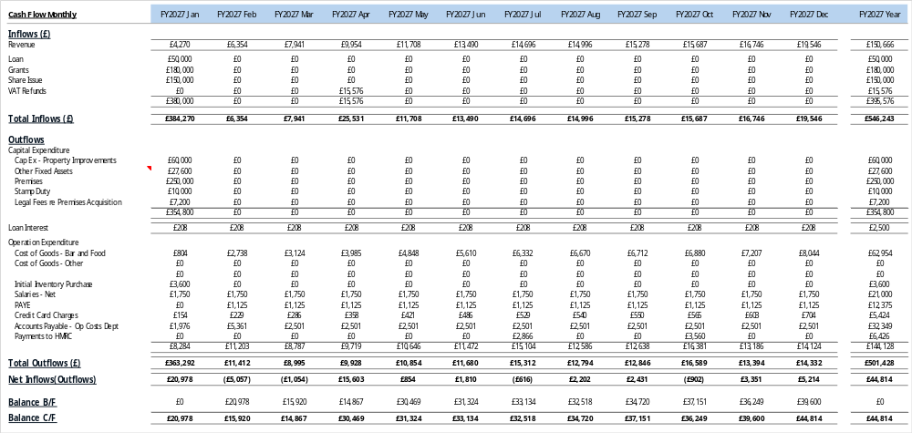

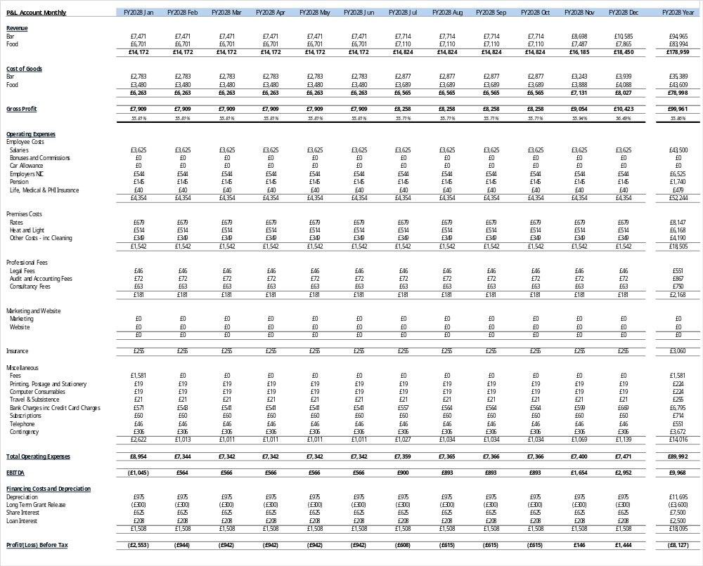
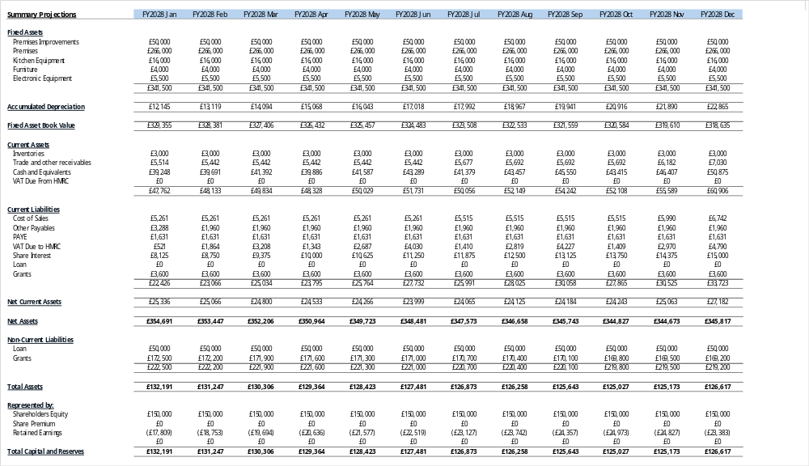

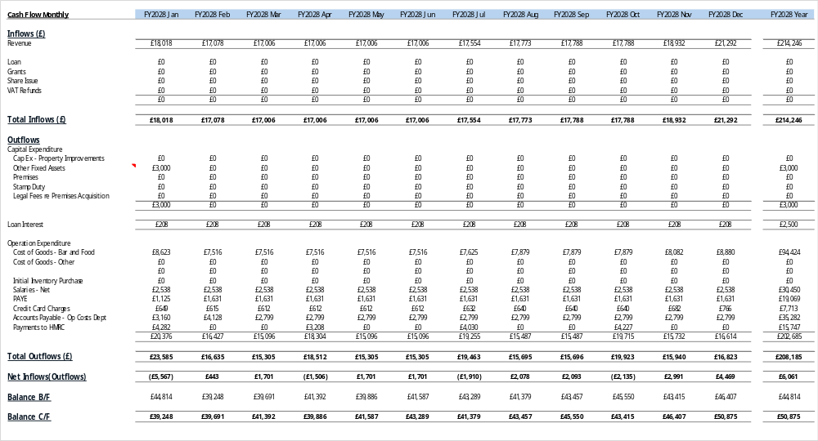

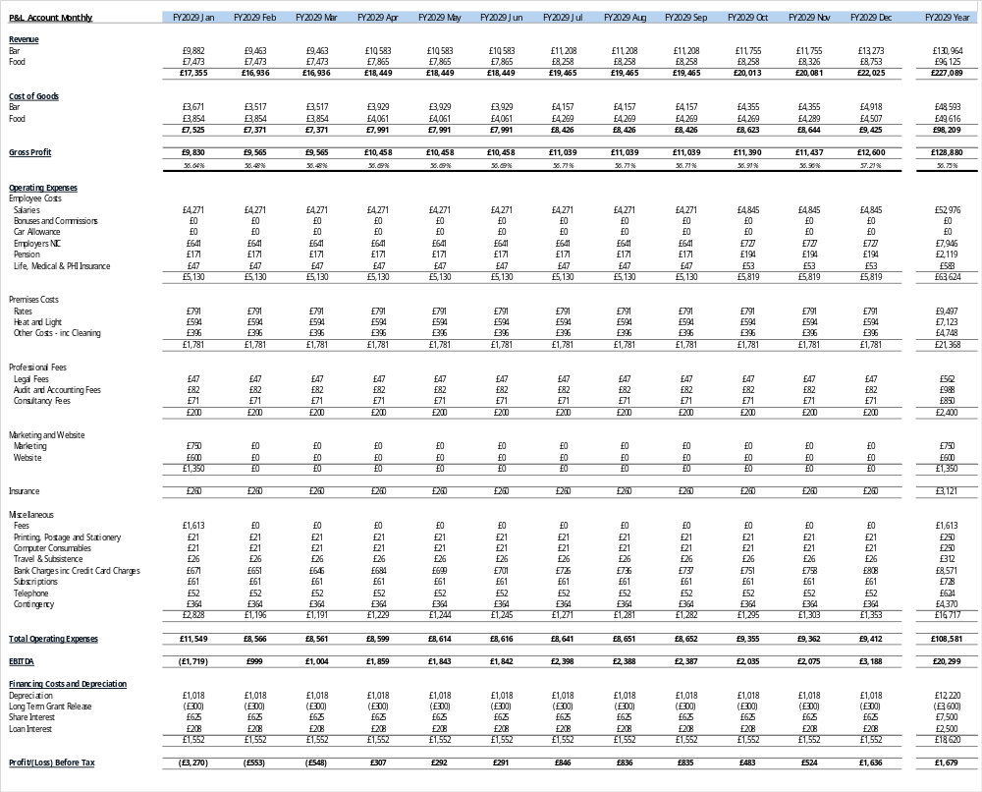
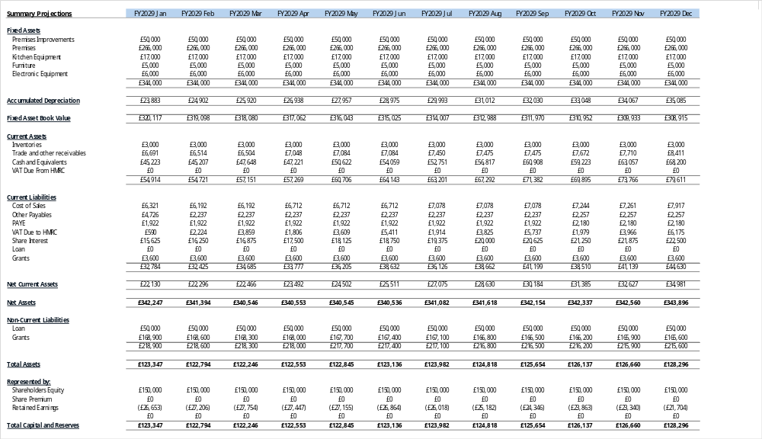

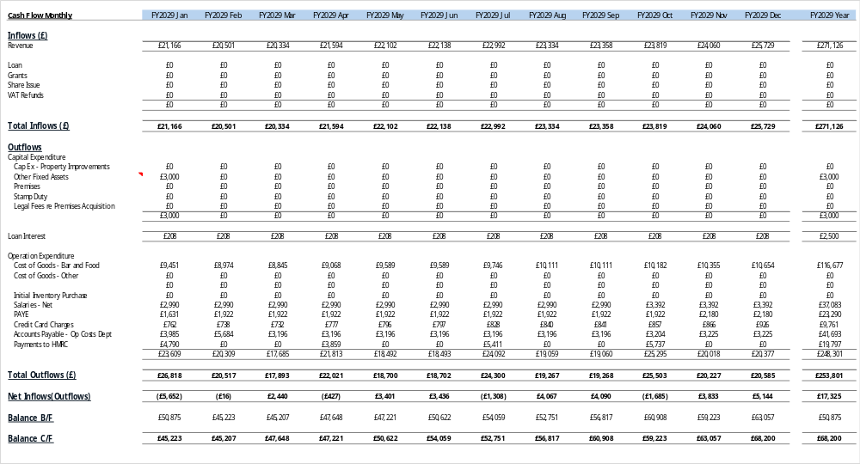

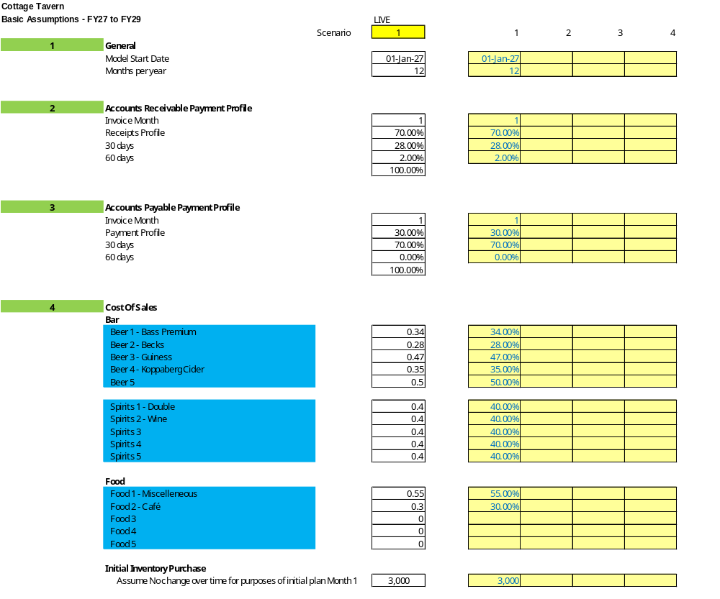
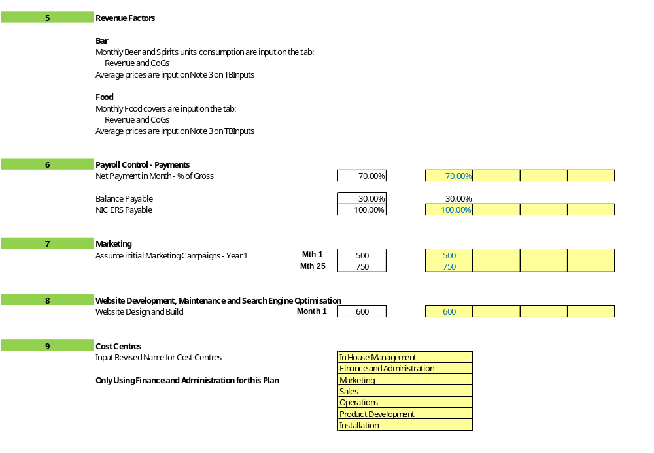

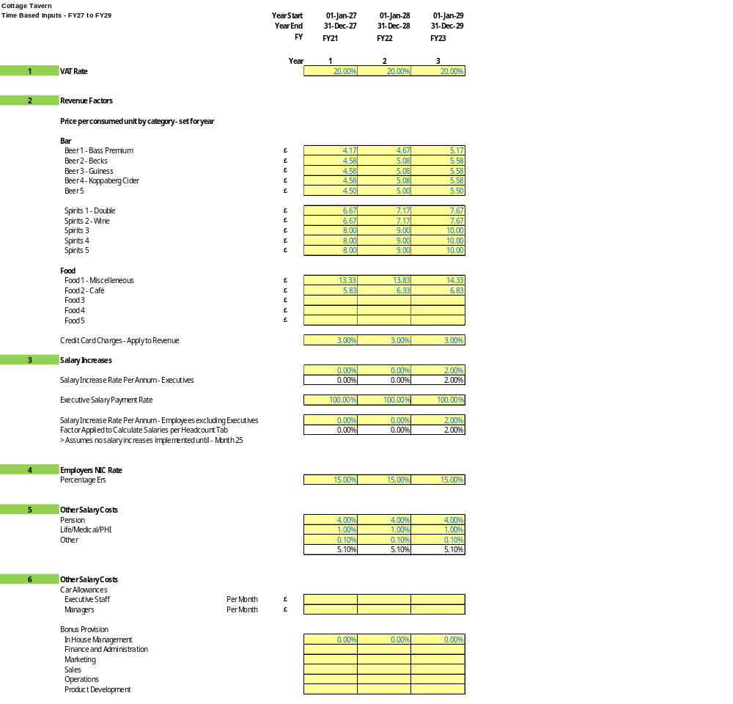
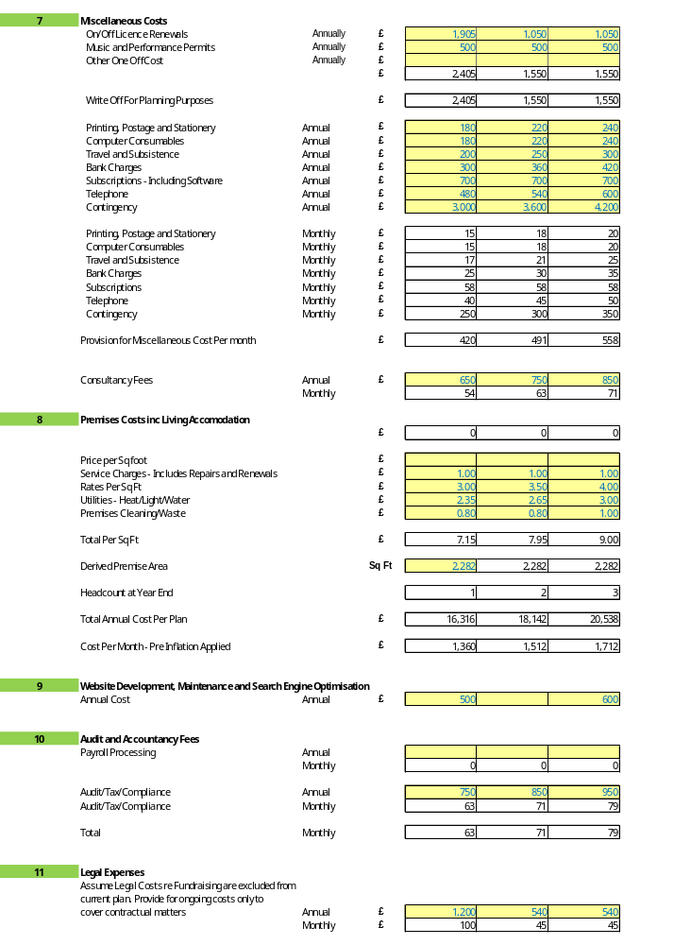
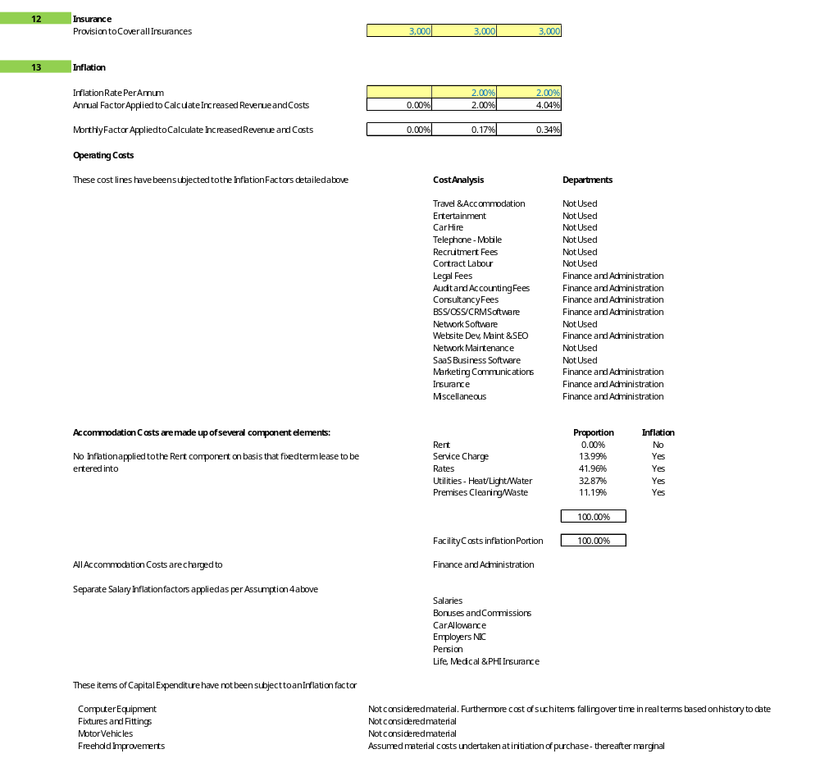
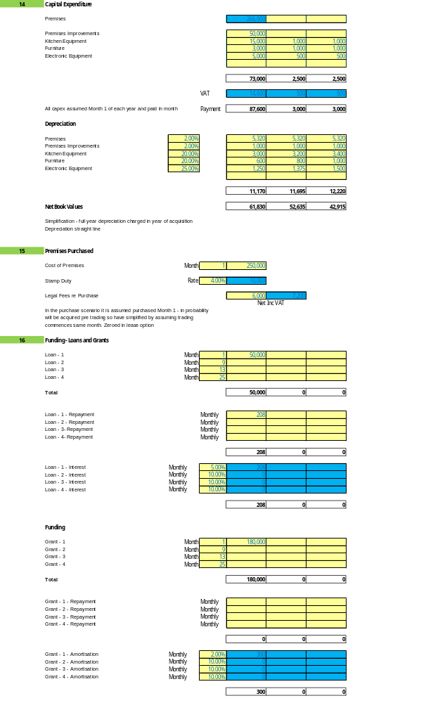
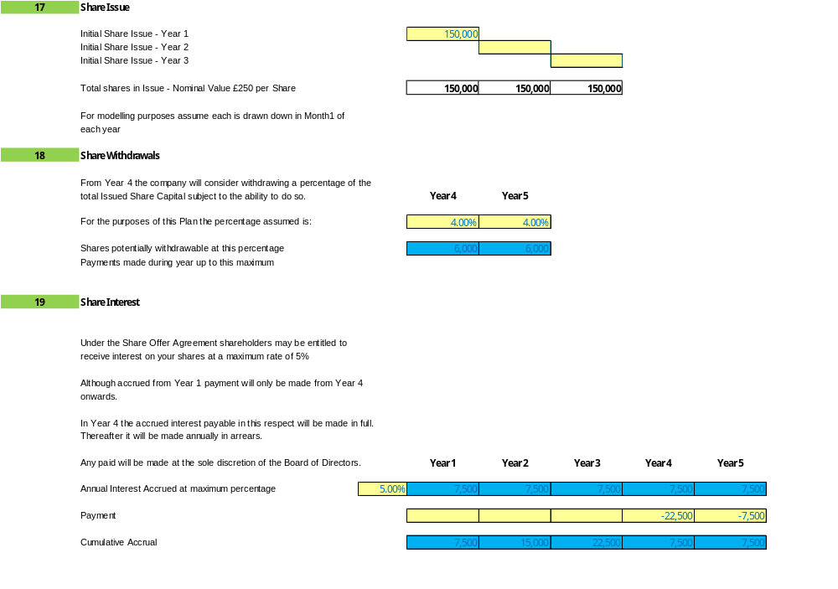
Appendix 7 Ashorne House Sales Data

- Protecting Our Village’s Heart:
Despite a very stable village housing situation for an extended period of time, as of July 2025, there were six properties for sale in Ashorne, Warwickshire
- £575,000 – Grade II Listed 4-bedroom cottage. Sold.
- £525,000 – Modern 3-bedroom detached house with countryside views.
- £450,000 – Detached 3-bedroom cottage with private parking and gardens. Sold
- £410,000 – Late Victorian 2-bedroom detached cottage.
- £425,000 – Detached 2-bedroom house with offroad parking.
- £300,000 – 2-bedroom terraced cottage in the village centre. Sold
As of today, four of the above have been sold, but many took longer to sell than previously and the existing owners had to lower their prices (often by tens of thousands of pounds). In addition, since this time, an additional seven houses have been put on the market –
In April 2026, the owners of a house that had recently been put on the market highlighted that the situation with the (lack of) village pub has directly caused a potential buyer to pull out .

